HASPPP User Manual

HASPPP: an open-source Galileo HAS embeddable RTKLIB decoding package

written by Runzhi Zhang, Rui Tu, Xiaochun Lu



**National Time Service Center,**

**Chinese Academy of Sciences**

Update: 2024.04.30

Contents

1 Introduction 1

2 Download 2

3 Install 3

3.1 Learning Project for Decoding Official HAS Data 3

3.2 Learning Project for Decoding Real-time Cashed HAS Data 5

3.3 PPP Project Using the RTKLIB Embedded with HASPPP 7

4 Compile and Package 12

4.1 Learning Project for Decoding Official HAS Data 12

4.1.1 Compile from Source Code 12

4.1.2 Package Executable Program 14

4.2 Learning Project for Decoding Real-time Cashed HAS Data 16

4.2.1 Compile from Source Code 16

4.2.2 Package Executable Program 18

4.3 PPP Project Using the RTKLIB Embedded with HASPPP 20

4.3.1 Compile from Source Code 20

4.3.2 Package Executable Program 23

5 Results and Verification 25

5.1 Learning Project for Decoding Official HAS Data 25

5.2 Learning Project for Decoding Cashed Real-time HAS Data 26

5.3 PPP Processing Using the RTKLIB Embedded with HASPPP 28

5.3.1 Data Preparation 28

5.3.2 Advanced Parameter Configuration 28

5.3.3 Output File Format 30

5.3.4 Positioning Results 32

5.3.5 PPP Time Comparison Results 33

6 Embedding HASPPP into C/C++ GNSS Software 35

6.1 Preparing Dependency Files 35

6.2 Working Directory 37

6.3 Embedding Details 38

Appendix 40

A. Receiver Configuration and Its HAS Data Format 40

A.1 China SINO 40

A.2 Septentrio 42

A.3 NovAtel 43

B. HASPPP Core Code Framework 45

B.1 Introduction to HAS Pages 45

B.2 Introduction to HAS Decoding and the HASPPP Program 47

C. Log Files of HASPPP Decoding Package 51

C.1 trace.txt 51

C.2 pid.txt 51

C.3 SSRA.bnc 52

C.4 clock.txt 53

References 54

Thanks & Support 55

Acronyms 55

Contact Us 56

# 1 Introduction

European Galileo navigation system aims to provide users with real-time high-precision precise point positioning (PPP) or PPP-RTK services by broadcasting globally satellite products and European regional atmospheric corrections for free via Galileo satellites, which is known as the high accuracy service (HAS) (EUSPA 2023b). On January 24, 2023, Galileo’s initial service was declared operational (EUSPA 2023a). The achievement of a horizontal positioning target of 20 cm has been demonstrated (de Blas et al. 2023; Fernandez-Hernandez et al. 2022; Naciri et al. 2023; Parra et al. 2023; Yi et al. 2023).

To improve the efficiency of receiving HAS message, HAS corrections are encoded into HAS encoded pages by high-parity vertical Reed–Solomon (HPVRS) (EUSPA 2022). These encoded pages, along with HAS page headers, are distributed to various Galileo satellites for broadcast. Upon receiving the HAS encoded pages, these must be decoded to recover the precise HAS product.

Python is efficient in mathematical computations; therefore, HAS decoders, including HASlib and GHASP, based on Python have been designed and developed (Borio et al. 2023; Horst et al. 2022). However, the majority of popular open-source global navigation satellite system (GNSS) software, such as RTKLIB, is developed using C/C++. To seamlessly integrate with mainstream GNSS software, an open-source C/C++ HAS data processing package HASPPP has been developed. This document serves as a user manual for the open-source HAS decoding package.

The HASPPP decoding package can seamlessly integrate into the current stable C/C++ GNSS software, RTKLIB, thereby conveniently supporting research and applications of both post-processing and real-time PPP algorithms. It offers support for binary output formats from multiple manufacturers, including Septentrio, NovAtel, and China SINO. This manual provides a detailed analysis of source code, enabling users to easily upgrade and port it to other open-source C/C++ mainstream GNSS software.

The remaining chapters are arranged as follows: Chapter 2 introduces the download of HASPPP, along with accessing the HAS dataset download website; HASPPP provides two learning projects for HAS decoding and a PPP project embedded with HASPPP; Chapter 3 covers the installation and running of HASPPP; Chapter 4 explains the compilation and software packaging; Chapter 5 covers software configuration, output formats, and results; Chapter 6 provides a detailed overview of embedding HASPPP into RTKLIB.

# 2 Download

No additional libraries need to be downloaded. The source code, executable files, and dependencies of HASPPP are all contained within the “*HASPPP*” folder. The contents included are as follow:

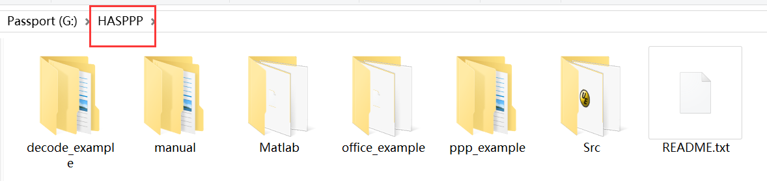

HAS binary data cannot be obtained from International GNSS Service (IGS) or International GNSS Monitoring and Assessment System (IGMAS) data centers. Currently, HASPPP supports decoding raw HAS data from three types of receivers (China SINO, NovAtel, and Septentrio). For convenience, we periodically provide cashed HAS binary data via [GitHub](https://github.com/ZhangRunzhi20/High-Accuracy-Service-public-dataset).

HASPPP is a specialized application package designed for receiving and processing HAS encoded pages. The source code and dependencies for processing the raw binary HAS data by HASPPP are stored in the folder “*HASPPP\Src*”. The contents of this folder are as follows:

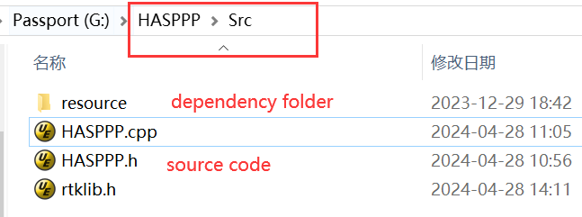

Furthermore, two learning projects (*office_example and decode_example*) for HAS decoding using HASPPP, and a PPP project (*ppp_example*) for embedding HASPPP into RTKLIB are provided. European Union Agency for the Space Programme (EUSPA) provided a set of HAS encoded pages, so we offer a learning project for processing these official HAS data using HASPPP. Additionally, a learning project for processing real-time raw binary cashed HAS data from three types of receivers is also provided. Different from real-time cached HAS data, the data provided by the official source omits the process of extracting HAS encoded pages from raw binary data.

# 3 Install

## 3.1 Learning Project for Decoding Official HAS Data

The learning project for decoding official data is in “*HASPPP\office_example*”. **Galileo-HAS-SIS-ICD-1.0_Annex_D_HAS_Message_Decoding_Example.txt** is an official example provided by Galileo HAS. Official HAS data is stored in “*HASPPP\office_example\data*”. The contents of the folder “*HASPPP\office_example*” are as follows:

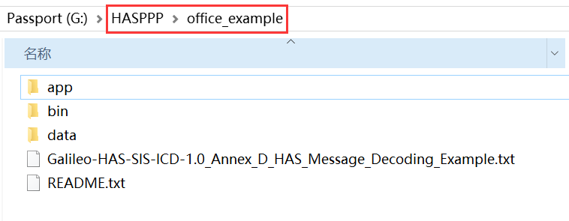

The executable file is in the “*HASPPP\office_example\bin*” folder. The execution of the HASPPP executable requires dependency folder “*resource*” and an empty log and decoding result folder “*debugFiles*”. If the dependency folder “*resource*” for HASPPP is missing, please copy it from “*HASPPP\Src*”. Please refer to Appendix C for the format of the files in the log folder “*debugFiles*”.

You can run it directly based on the corresponding operating system, ensuring only that the dependency folder “*resource*” and output folder “*debugFiles*” are positioned correctly, as shown below:

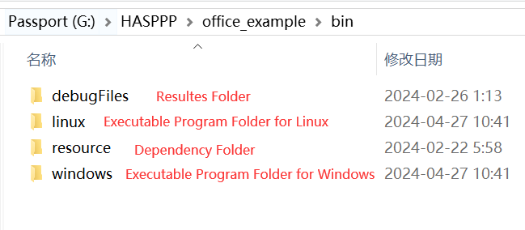

NOTE: regardless of whether it's Windows or Linux operating system, the folder “*debug*” containing the HAS decoding executable should be in the same directory as “*debugFiles*” and “*resource*”, and both folders should not be missing.

* Windows users (Windows 10-x64 tested):

Startup programs via command line in “*CMD*”:

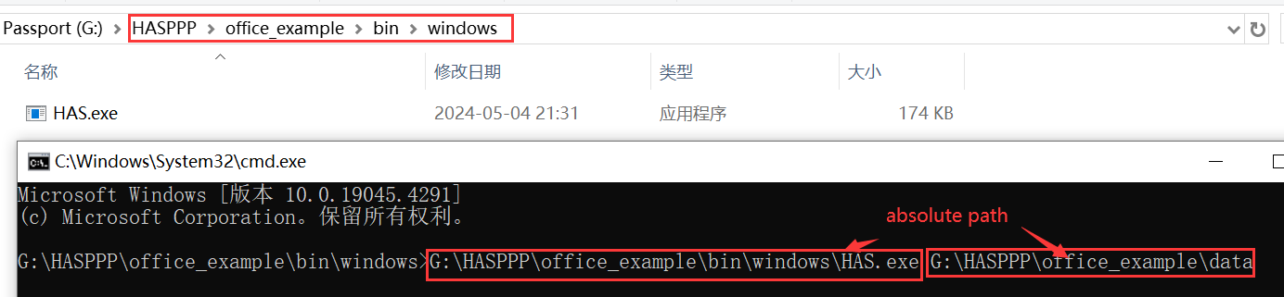

* Linux users (Ubuntu 18.04-x64 tested):

Startup programs via command line in “*CMD*”:

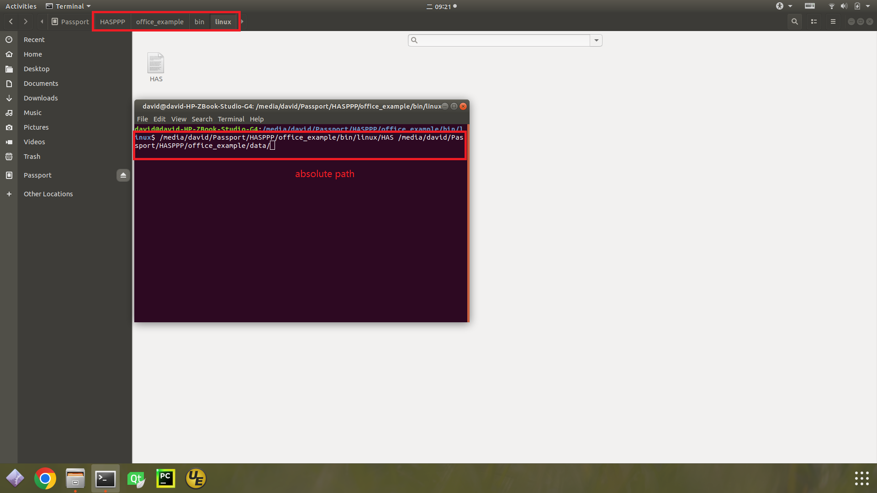

NOTE: The executable program requires the address of the official HAS data as an input parameter, and it only supports absolute paths for both the executable program and input data.

## 3.2 Learning Project for Decoding Real-time Cashed HAS Data

The learning project for decoding cashed real-time HAS data is placed in “*HASPPP\decode_example*”. HAS raw binary data (**\*.HAS**) cashed by three types of receivers is provided in the folder “*HASPPP\decode_example\data*”. The contents of the folder “*HASPPP\decode_example*” are as follows:

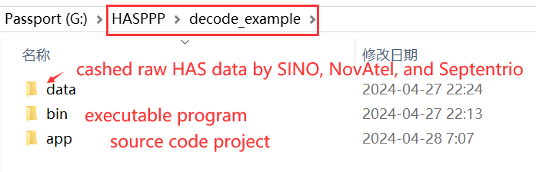

The executable file is in the “*HASPPP\decode_example\bin*” folder. Please ensure that both the dependency folder “*resource*” and the empty log folder “*debugFiles*” exist and are located correctly before executing the executable file. If the dependency folder “*resource*” for HASPPP is missing, please copy it from “*HASPPP\Src*”. The contents of folder “*HASPPP\decode_example\bin*”, when it is complete and correct, are as follows:

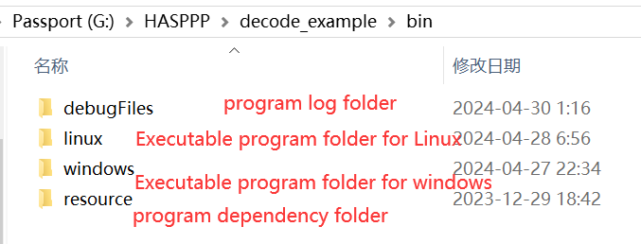

* Windows users (Windows 10-x64 tested):

Startup programs via command line in “*CMD*”:

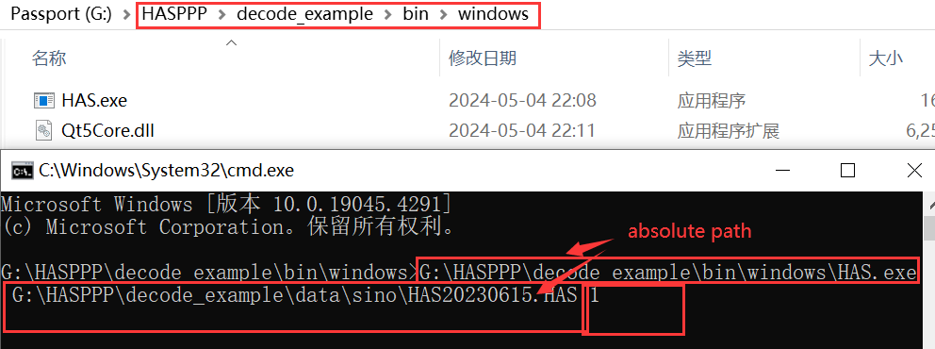

* Linux users (Ubuntu 18.04-x64 tested):

Startup programs via command line in “*CMD*”:

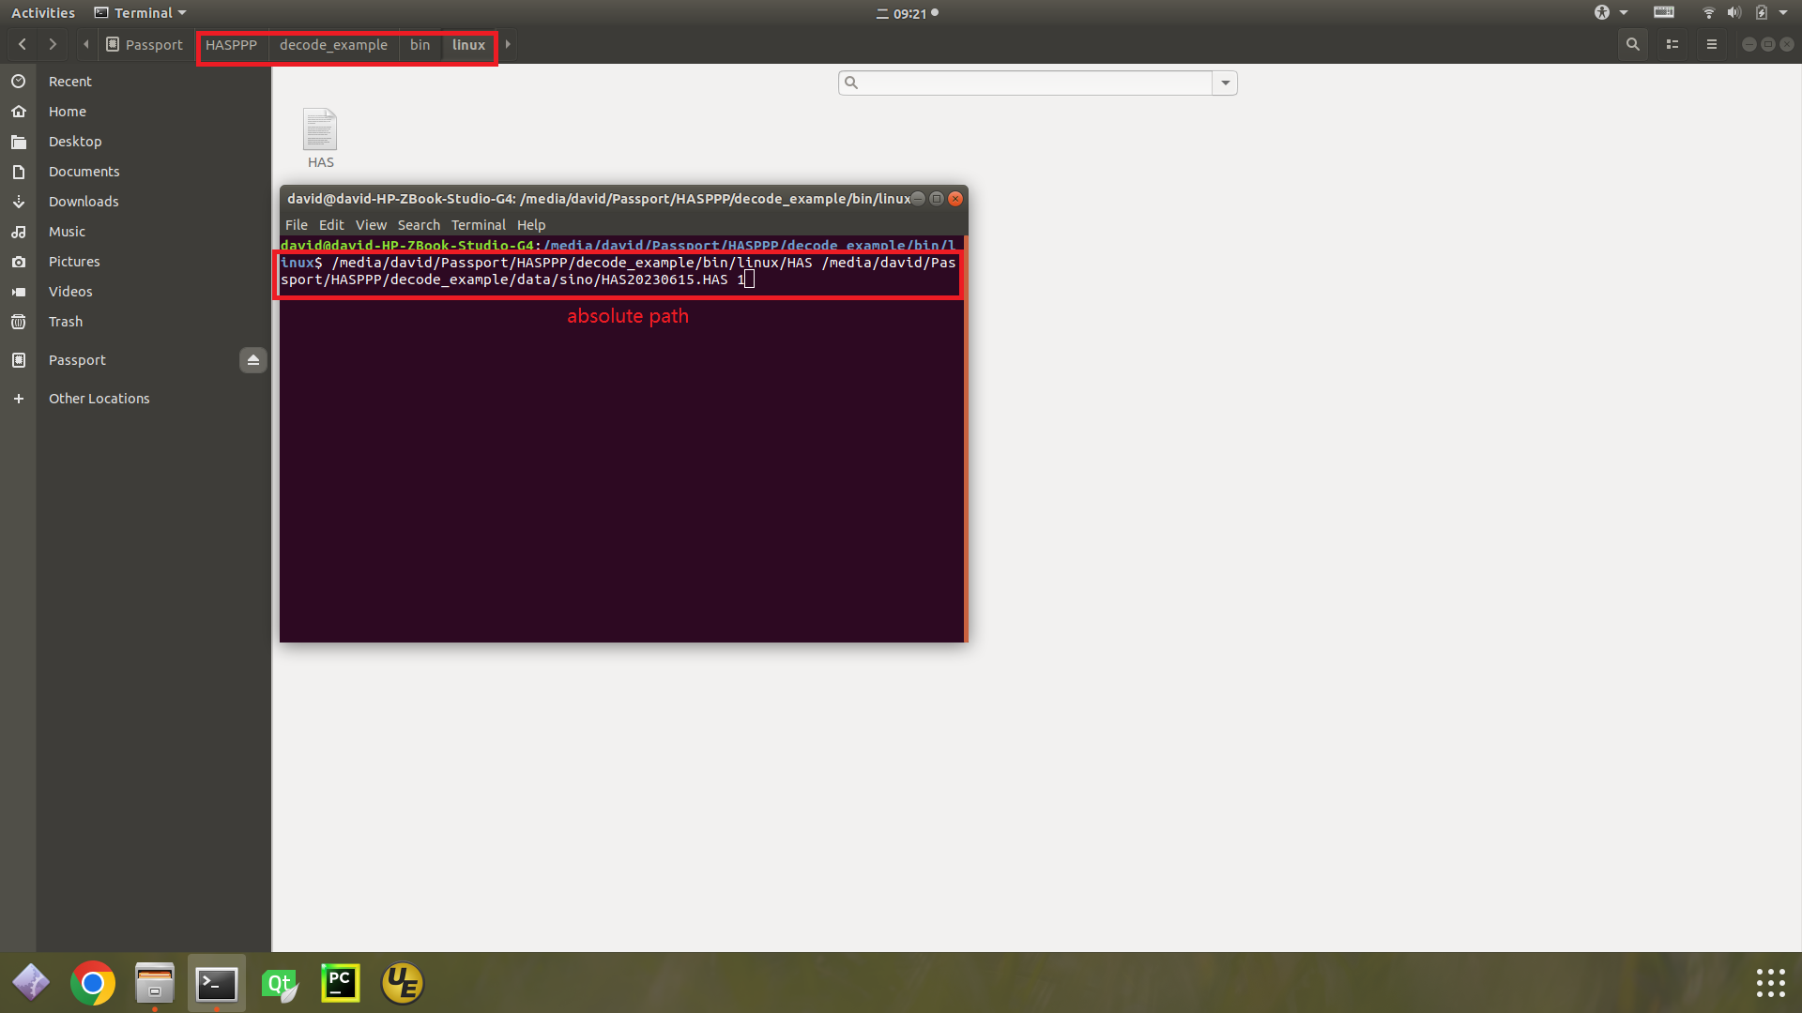

NOTE: The executable program requires two input parameters: the absolute path of the data and the identifier of the receiver for the data to be decoded. It only supports absolute paths for both the executable program and the input data.

The program needs to determine the type of receiver outputting the HAS raw binary data via the second input parameter. If the HAS data is cached by SINO receivers, the second input parameter should be “1”; for NovAtel receivers, it should be “2”; and for Septentrio receivers, it should be “3”.

## 3.3 PPP Project Using the RTKLIB Embedded with HASPPP

The provided RTKLIB execution program has removed the graphical interface and optimized the solution program. The PPP project embedded with HASPPP is in “*HASPPP\ppp_example*”. HAS raw binary data (**\*.HAS**) cashed by three types of receivers is provided in the folder “*HASPPP\ppp_example\data*”. The contents of the folder “*HASPPP\ppp_example*” are as follows:

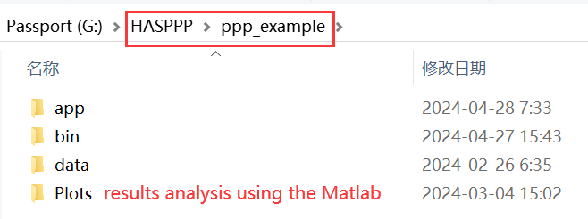

The executable file is in the “*HASPPP\ppp_example\bin*” folder. Please ensure that both the dependency folder “*resource*” and the empty log folder “*debugFiles*” exist and are located correctly before executing the executable file. If the dependency folder “*resource*” for HASPPP is missing, please copy it from “*HASPPP\Src*”. The contents of folder “*HASPPP\ppp_example\bin*”, when it is complete and correct, are as follows:

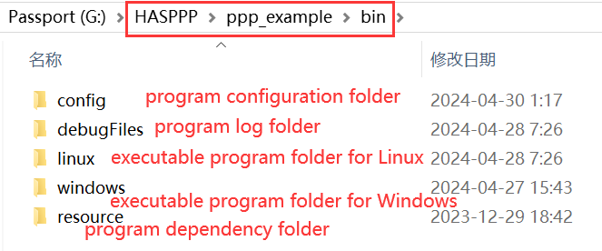

1. Configure the paths for the required files for PPP
2. Open the graphical user interface configuration software in the “*config*” folder

* Windows users (Windows 10-x64 tested, double-click on **rtkpost.exe**):

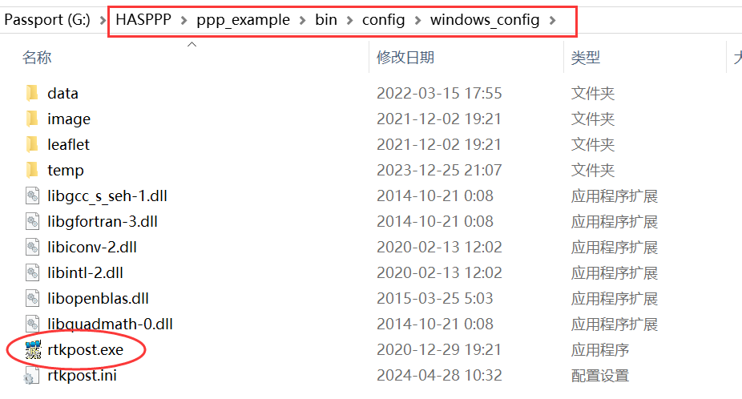

* Linux users (Ubuntu 18.04-x64 tested, command line):

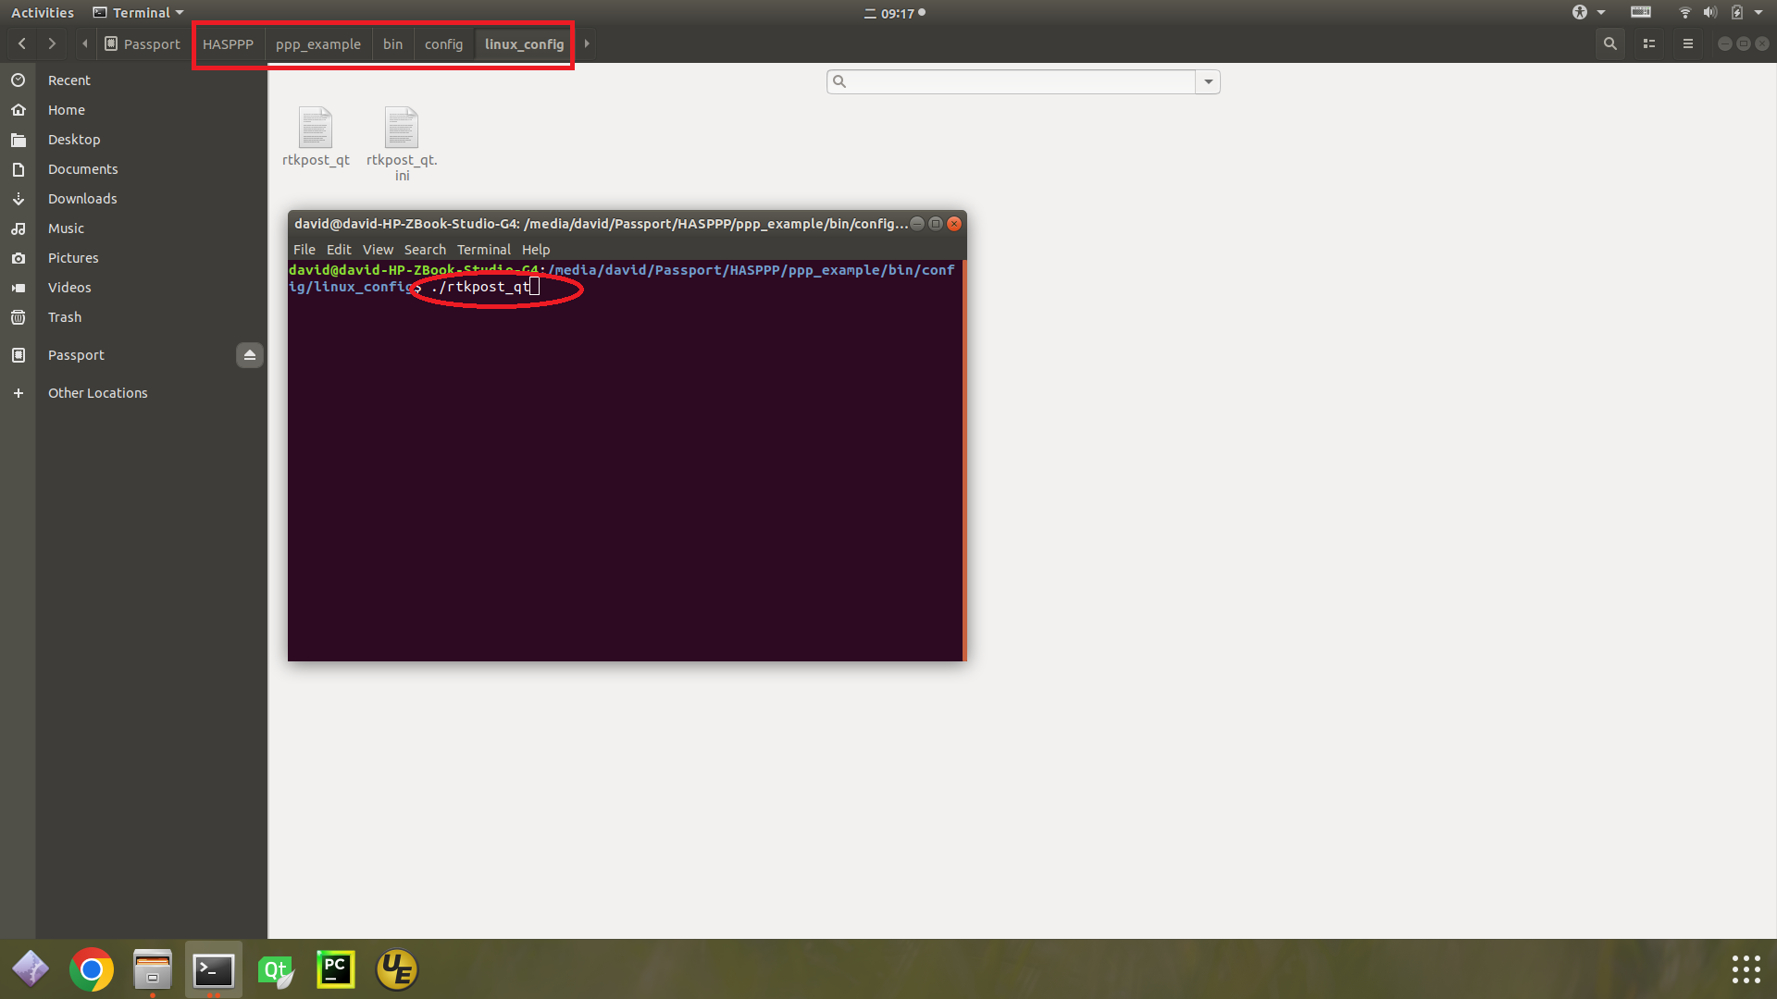

1. Set the path for the antenna file

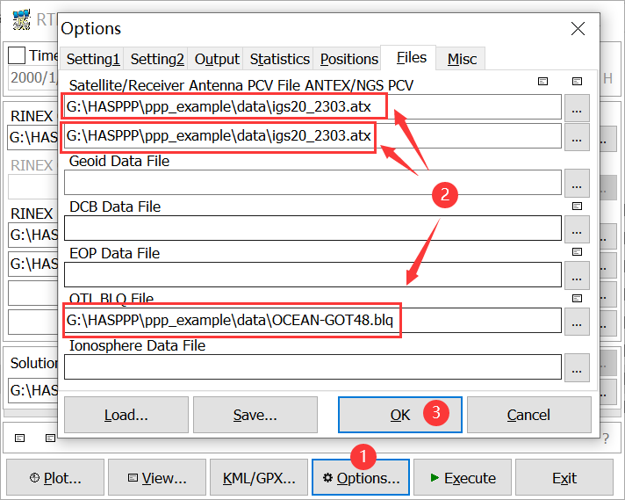

1. Set the antenna type of the receiver

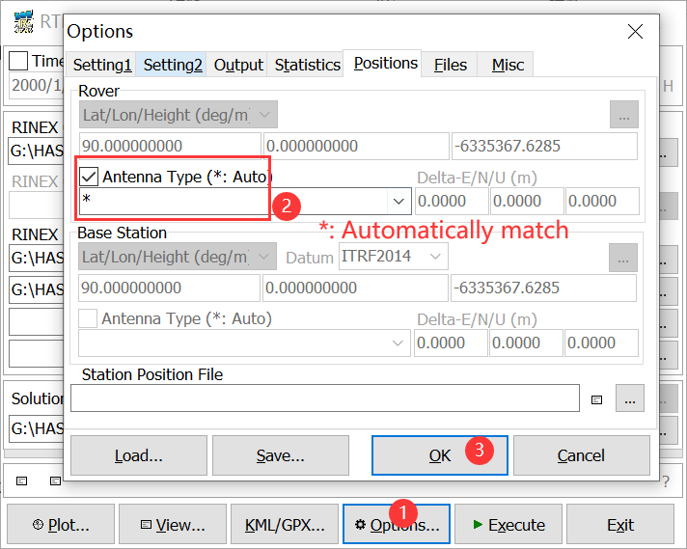

1. Set the paths for input and output files and save settings

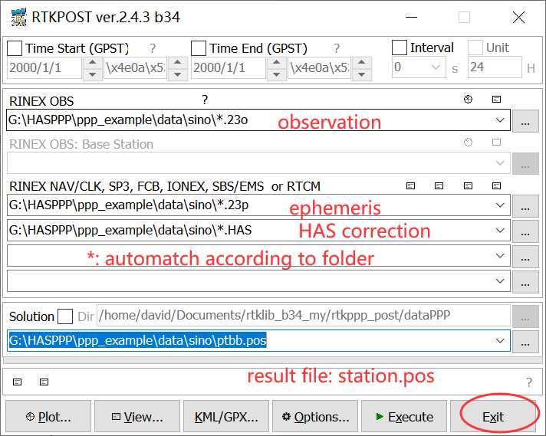

NOTE: The saved configuration file (**\*.ini**) will be generated in the folder “*windows_config*” for Windows users and the folder “*linux_config*” for Linux users.

1. Copy configuration file to “*HASPPP\ppp_example\bin\config*”

For Windows users, copy the file “HASPPP\ppp_example\bin\config\windows_config\**rtkpost.ini**” to the “*HASPPP\ppp_example\bin\config*” folder;

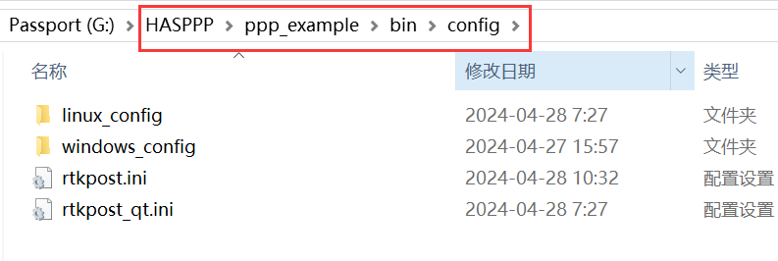

For Linux users, copy the file “HASPPP\ppp_example\bin\config\linux_config\**rtkpost_qt.ini**” to the “*HASPPP\ppp_example\bin\config*” folder.

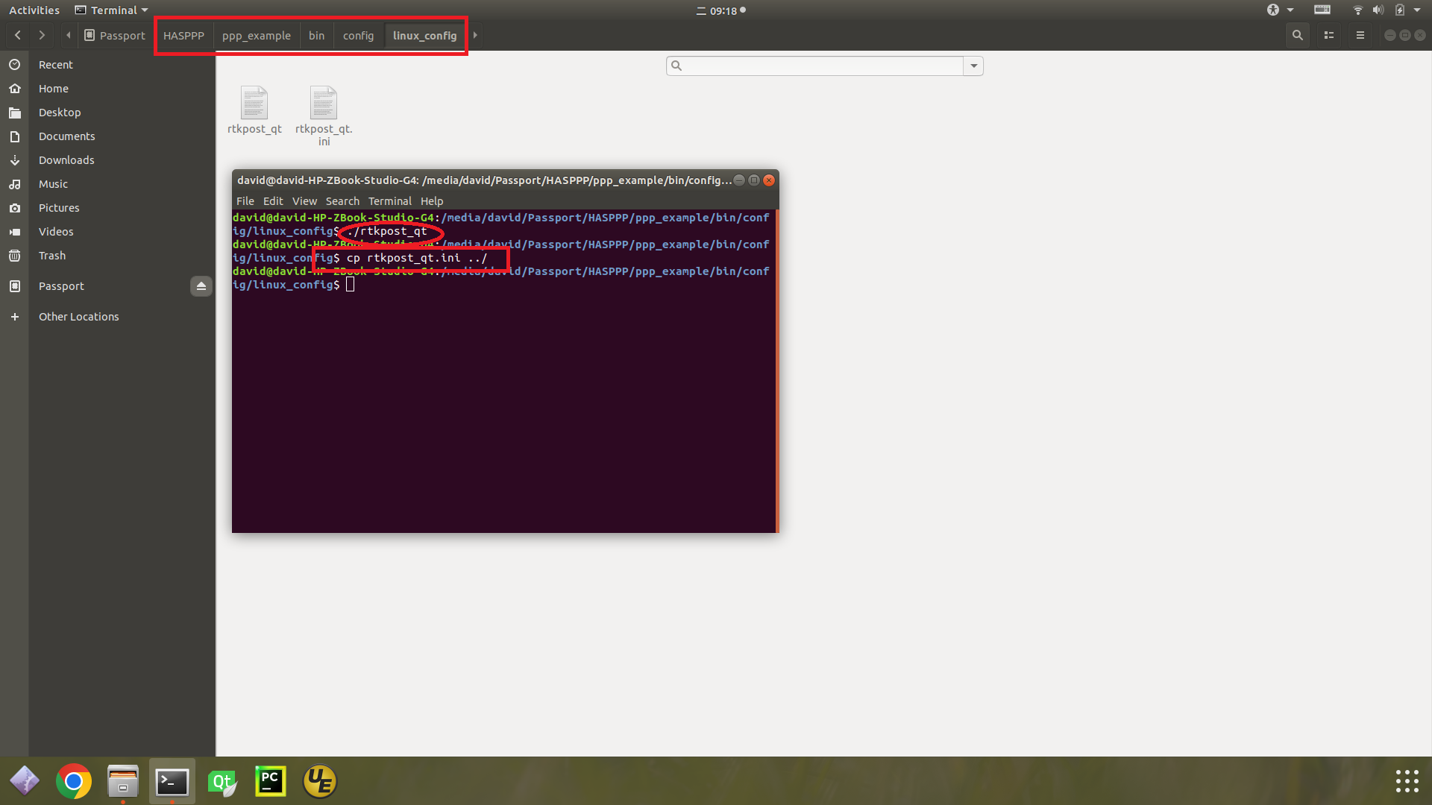

NOTE: The PPP program reads the configuration file from the “*config*” folder.

1. Startup programs via command line in “*CMD*”:

* Windows users (Windows 10-x64 tested):

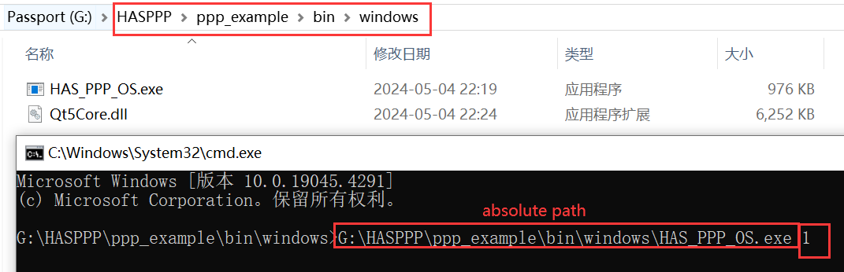

* Linux users (Ubuntu 18.04-x64 tested):

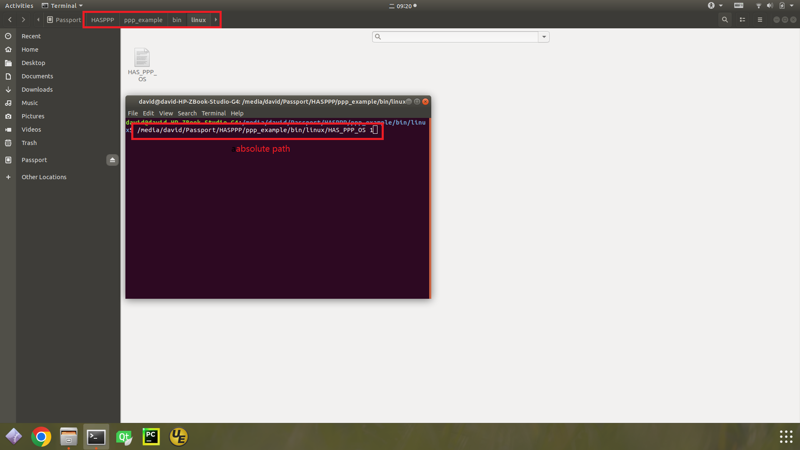

NOTE: The executable program requires one input parameter: the identifier of the receiver for the data to be processed. It only supports absolute path for the executable program.

The input parameter for program execution needs to be selected according to the type of receiver that outputs HAS corrections. If the data is from SINO receivers, the input parameter should be set to “1”; for NovAtel receivers, set it to “2”; and for Septentrio receivers, set it to “3”. Data is stored according to the type of receiver as follows:

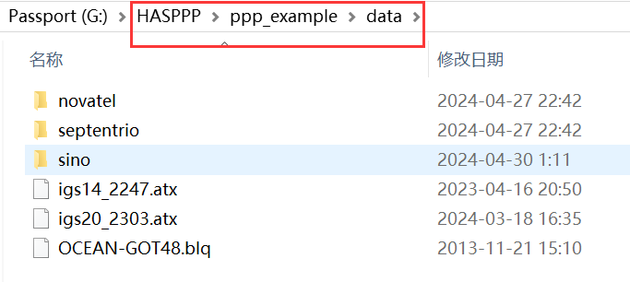

# 4 Compile and Package

## 4.1 Learning Project for Decoding Official HAS Data

### 4.1.1 Compile from Source Code

You can compile the source code of this project using QT.

1. Preparation

Before proceeding with HASPPP project, ensure you first install QT from the official website (<www.qt.io>). Once QT installation is completed, verify that the integrated development environment is correctly configured. HASPPP has been tested on Windows with “MinGW 5.12.12 64-bit” and on Linux with “GCC 5.8.0 64-bit” environments.

1. Open project

Open the file “HASPPP\office_example\app\**HAS.pro**” with QT and proceed to configure the project as shown below:

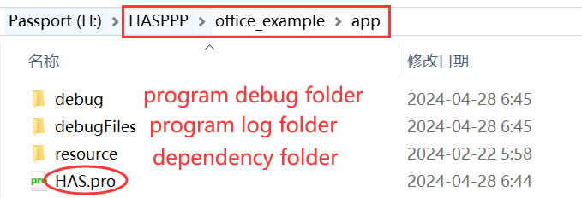

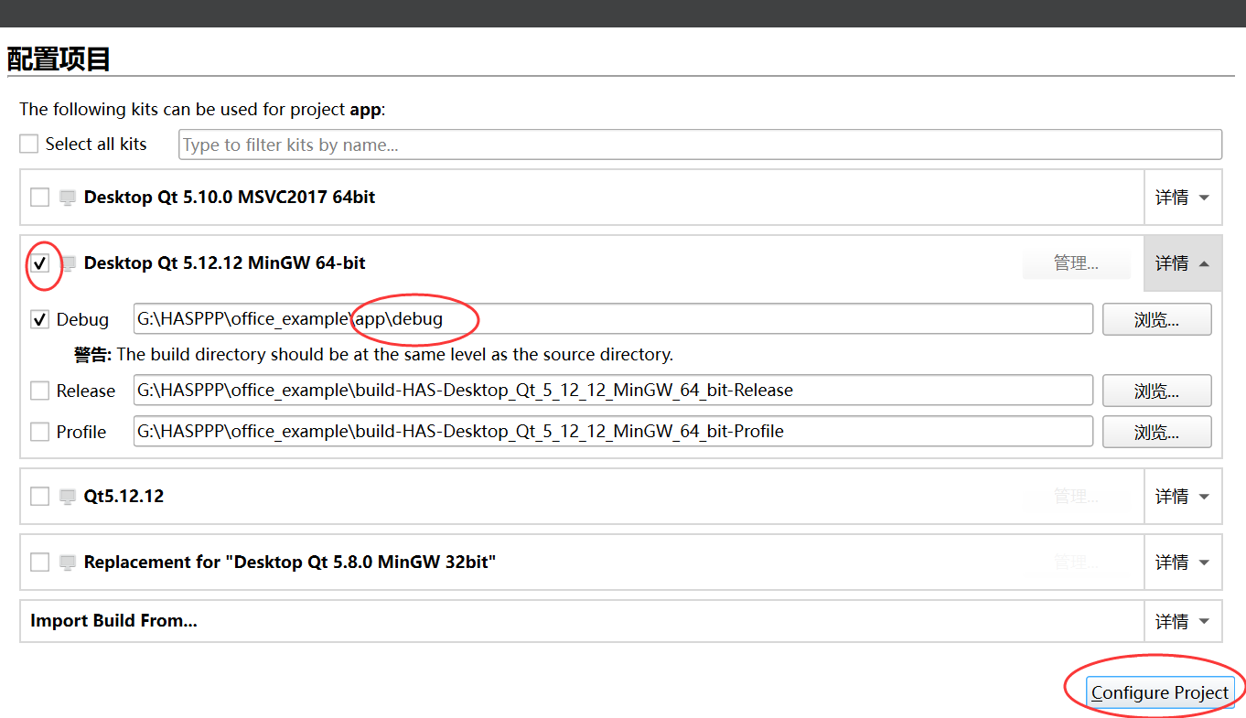

1. Build and configure with command-line parameter

Verify the correctness of the **.pro** file, especially ensure that the parameters highlighted in the *red box* in the image below. Once verified, initiate the build by clicking the *red circle* as indicated in the image.

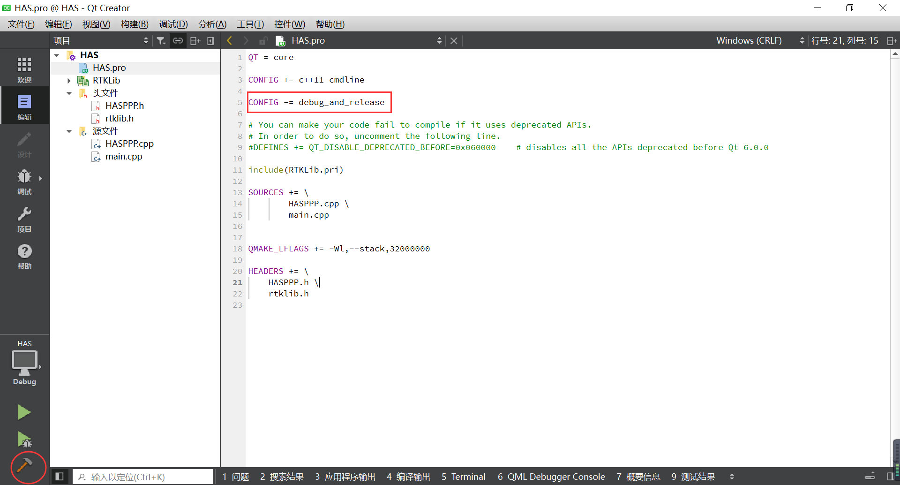

Configure the input data parameter (absolute path of official HAS data) for the program:

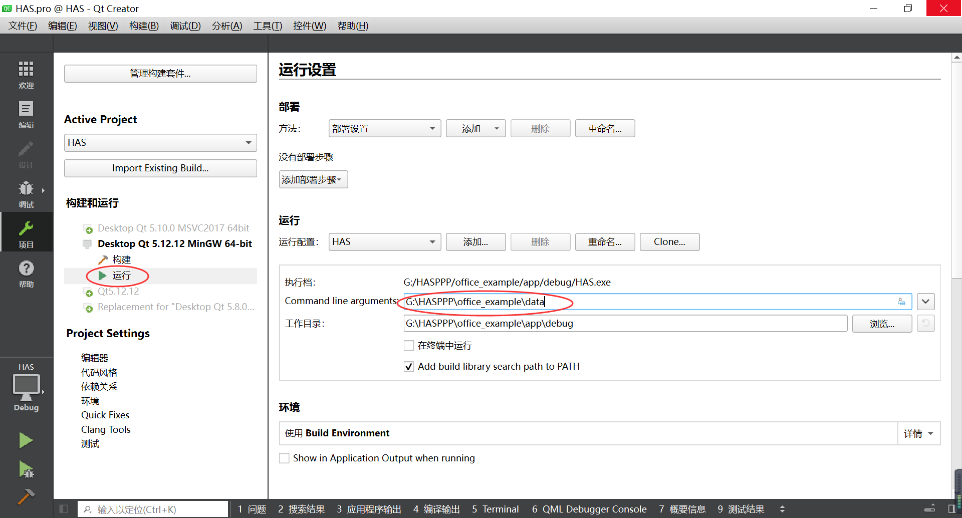

1. Copy dependency files

Create an empty “*debugFiles*” folder and copy the “*HASPPP\Src\resource*” folder to the same directory as the “*debug*” folder, as shown below:



1. Run

Debug and run this case by clicking on the *red circle* as shown below:

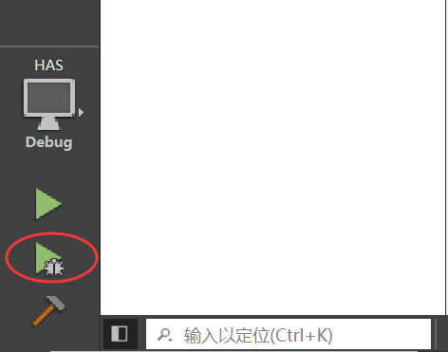

### 4.1.2 Package Executable Program

Users can package the executable program with QT as follow:

1. Run in Release mode in QT creator to generate executable file:



1. Package program

* Windows users (MinGW 5.12.12 64-bit):

**HAS.exe** should be moved to an “*example/release*” folder. Then “cd” to the folder and “windeployqt” **HAS.exe** in “*CMD*”.

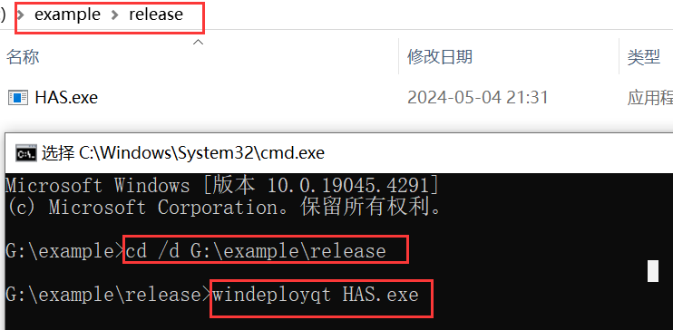

* Linux users (GCC 5.8.0 64-bit):

All the relevant library files must be included, otherwise the program cannot run successfully (Command “*ldd HAS*” can list all the library files of **HAS** in “Terminal” for checking), as shown below:

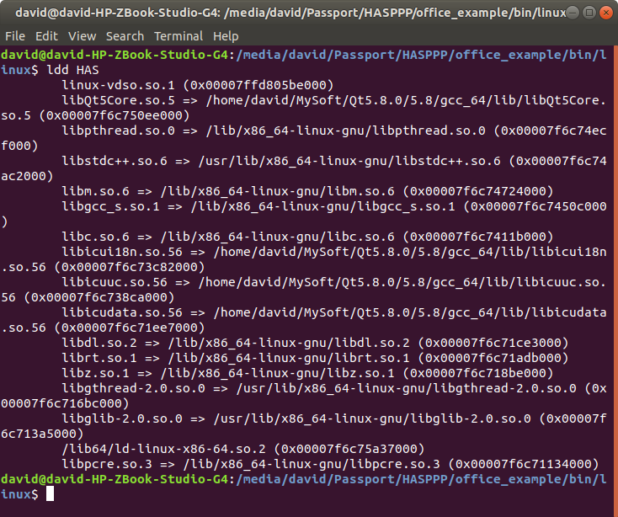

1. Prepare dependencies

Create an empty “*debugFiles*” folder and copy the “*HASPPP\Src\resource*” folder to the same directory as the “*release*” folder, as shown below:

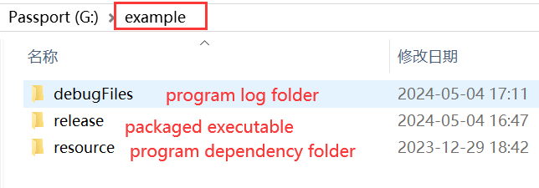

So far, the packaging is complete! **HAS** in the “*example*” folder can run as demonstrated in Section 3.1.

## 4.2 Learning Project for Decoding Real-time Cashed HAS Data

### 4.2.1 Compile from Source Code

You can compile the source code of this project using QT.

1. Open project

Open file “HASPPP\decode_example\app\**HAS.pro**” with QT:

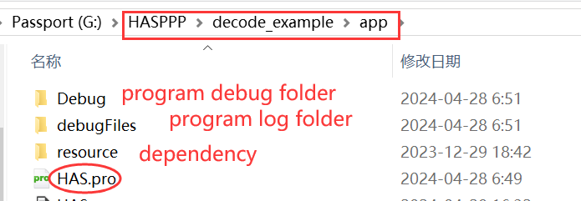

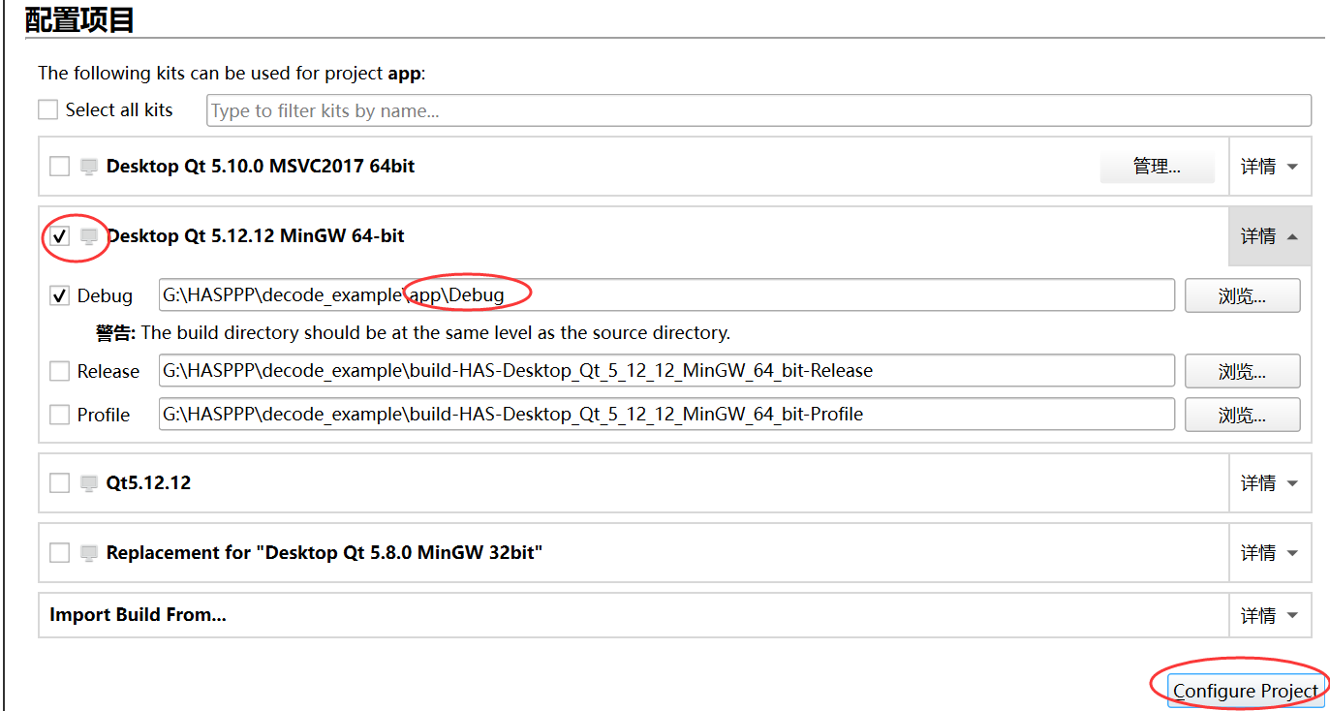

1. Build and configure with command-line parameters (MinGW 5.12.12 64-bit, tested)

Build HASPPP project by clicking the *red circle*, as shown below:

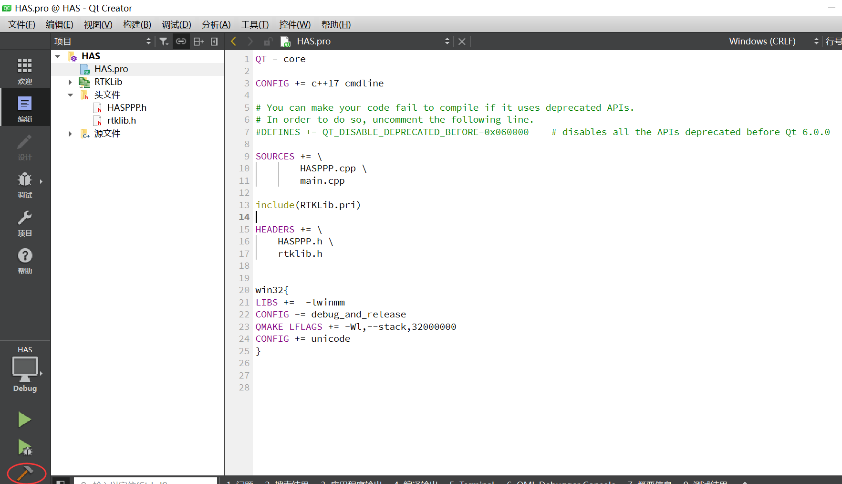

Configure input parameters (path of cashed real-time HAS data and identifier of the receiver) for program:

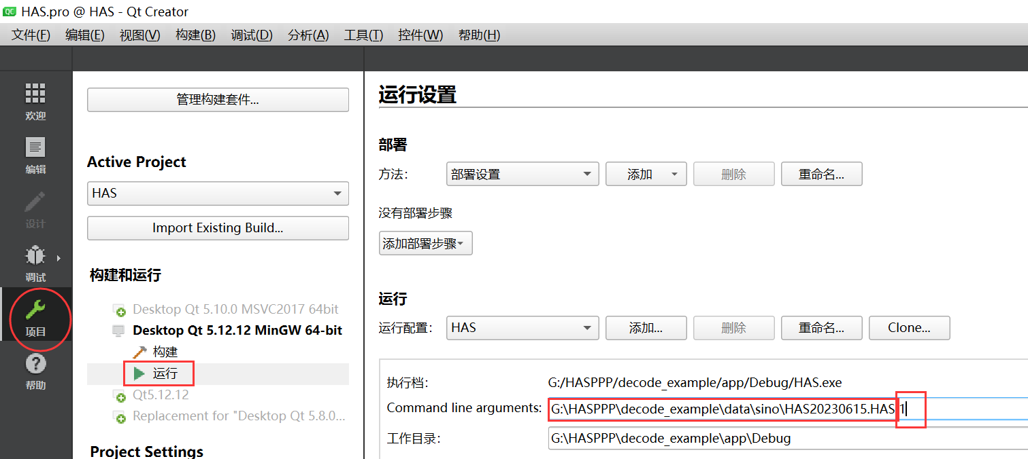

1. Copy dependency files

Create an empty “*debugFiles*” folder and copy the “*HASPPP\Src\resource*” folder to the same directory as the “*Debug*” folder, as shown below:

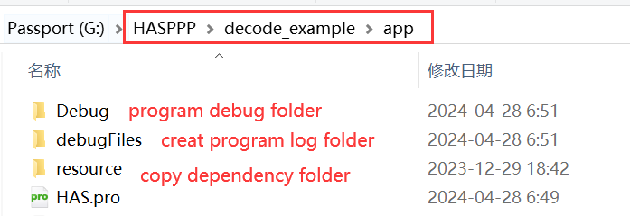

1. Run

Debug and run this case by clicking *red circle*, as shown below:

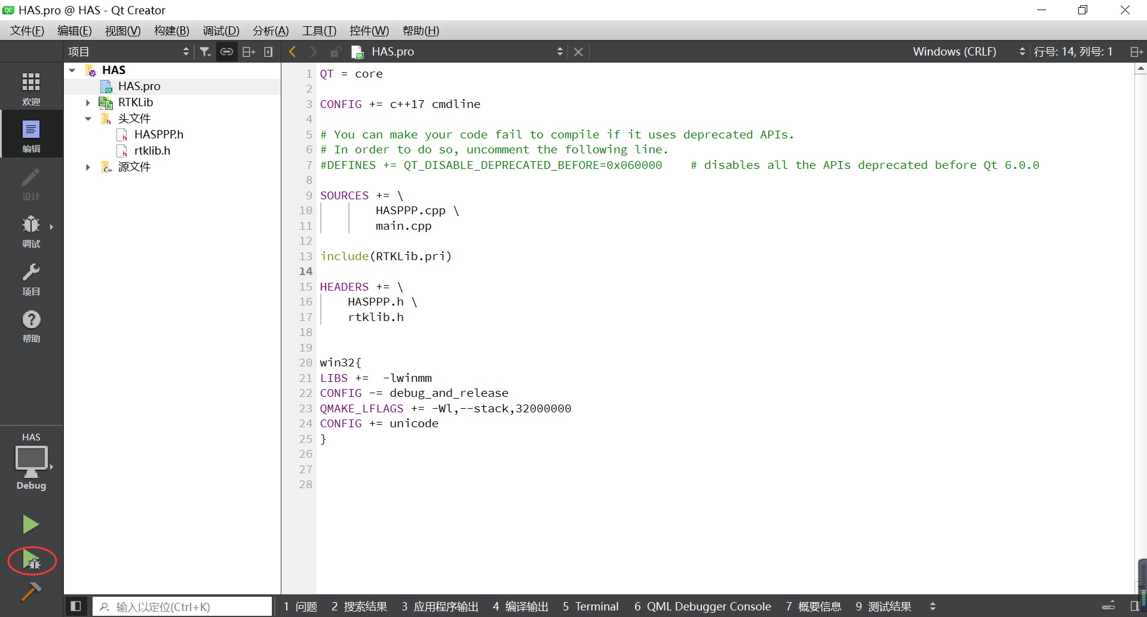

### 4.2.2 Package Executable Program

Users can package the executable program with QT as follow:

1. Run in Release mode in QT creator to generate executable file **HAS**:



1. Package program

* Windows users (MinGW 5.12.12 64-bit):

**HAS.exe** should be moved to an “*example/release*” folder. Then “cd” to the folder and “windeployqt” **HAS.exe** in “*CMD*”.



* Linux users (GCC 5.8.0 64-bit):

All the relevant library files must be included, otherwise the program cannot run successfully (Command “*ldd HAS*” can list all the library files of **HAS** in “Terminal” for checking), as shown below:

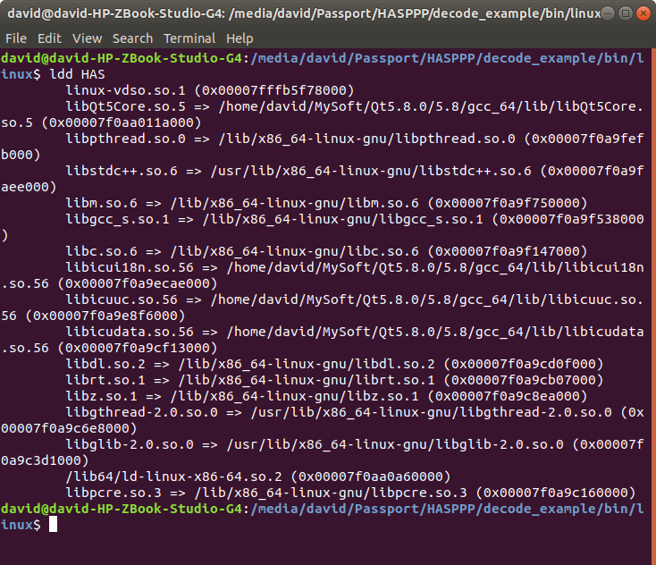

1. Prepare dependencies

Create an empty “*debugFiles*” folder and copy the “*HASPPP\Src\resource*” folder to the same directory as the “*release*” folder, as shown below:



So far, the packaging is complete! **HAS** in the “*example*” folder can run as demonstrated in Section 3.2.

## 4.3 PPP Project Using the RTKLIB Embedded with HASPPP

### 4.3.1 Compile from Source Code

You can compile the source code of this project using QT.

1. Configure configuration file in the “*HASPPP/ppp_example/app/config*” folder.

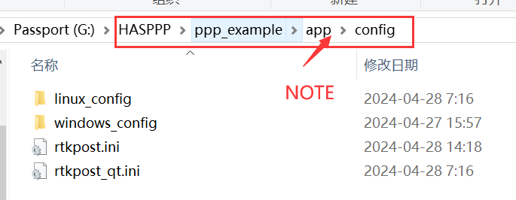

The detailed configuration methods have been explained in Section 3.3, interface configuration.

NOTE: The interface configuration methods for Section 3.3 and 4.3.1 are the same, but the paths are different.

1. Open project

Open file “HASPPP\ppp_example\app\**HAS_PPP_OS.pro**” with QT

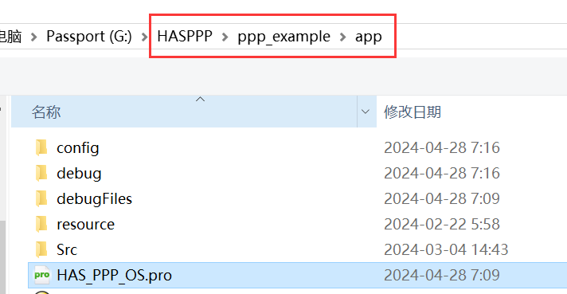

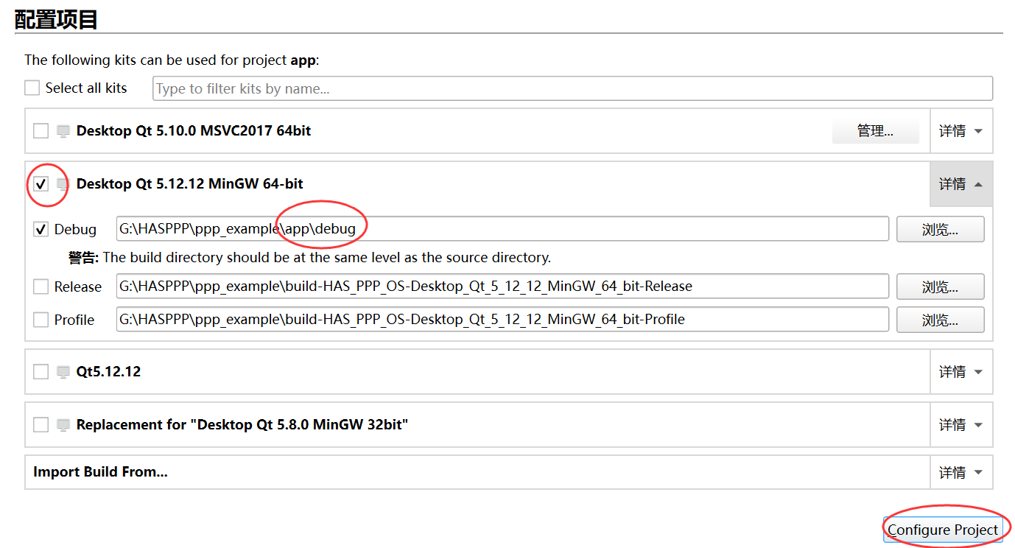

1. Build and configure with command-line parameters (MinGW 5.12.12 64-bit, tested)

Build HASPPP by clicking the *red circle*, as shown below:

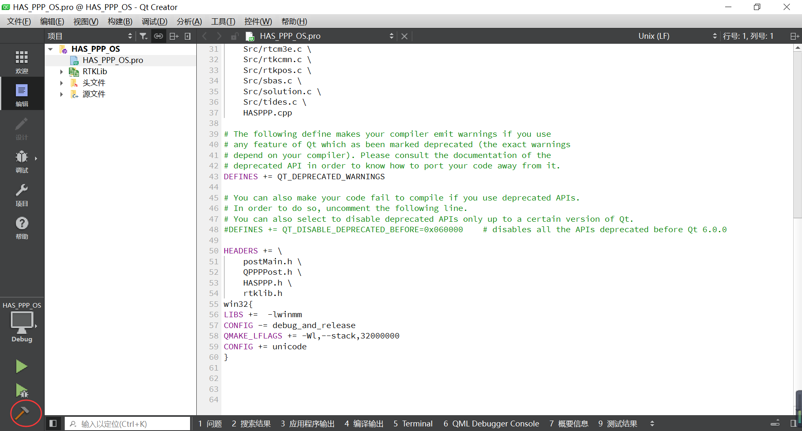

Configure input parameter (Identifier of the receiver) for the program:

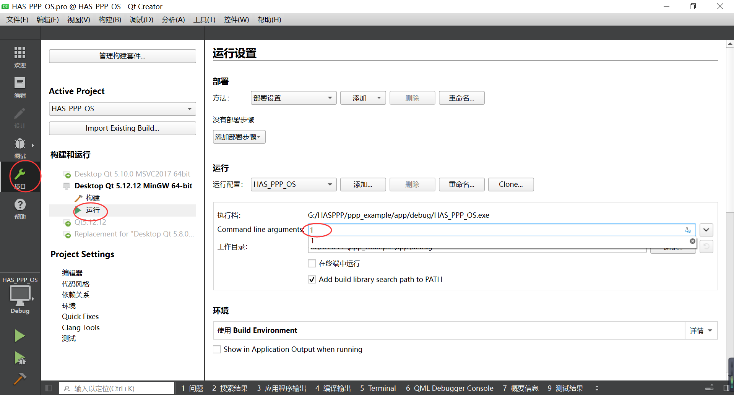

1. Copy dependency files

Create an empty “*debugFiles*” folder and copy the “*HASPPP\Src\resource*” folder to the same directory as the “*debug*” folder, as shown below:

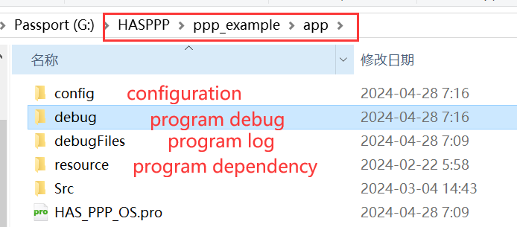

1. Run

Debug and run this case by clicking *red circle*, as shown below:

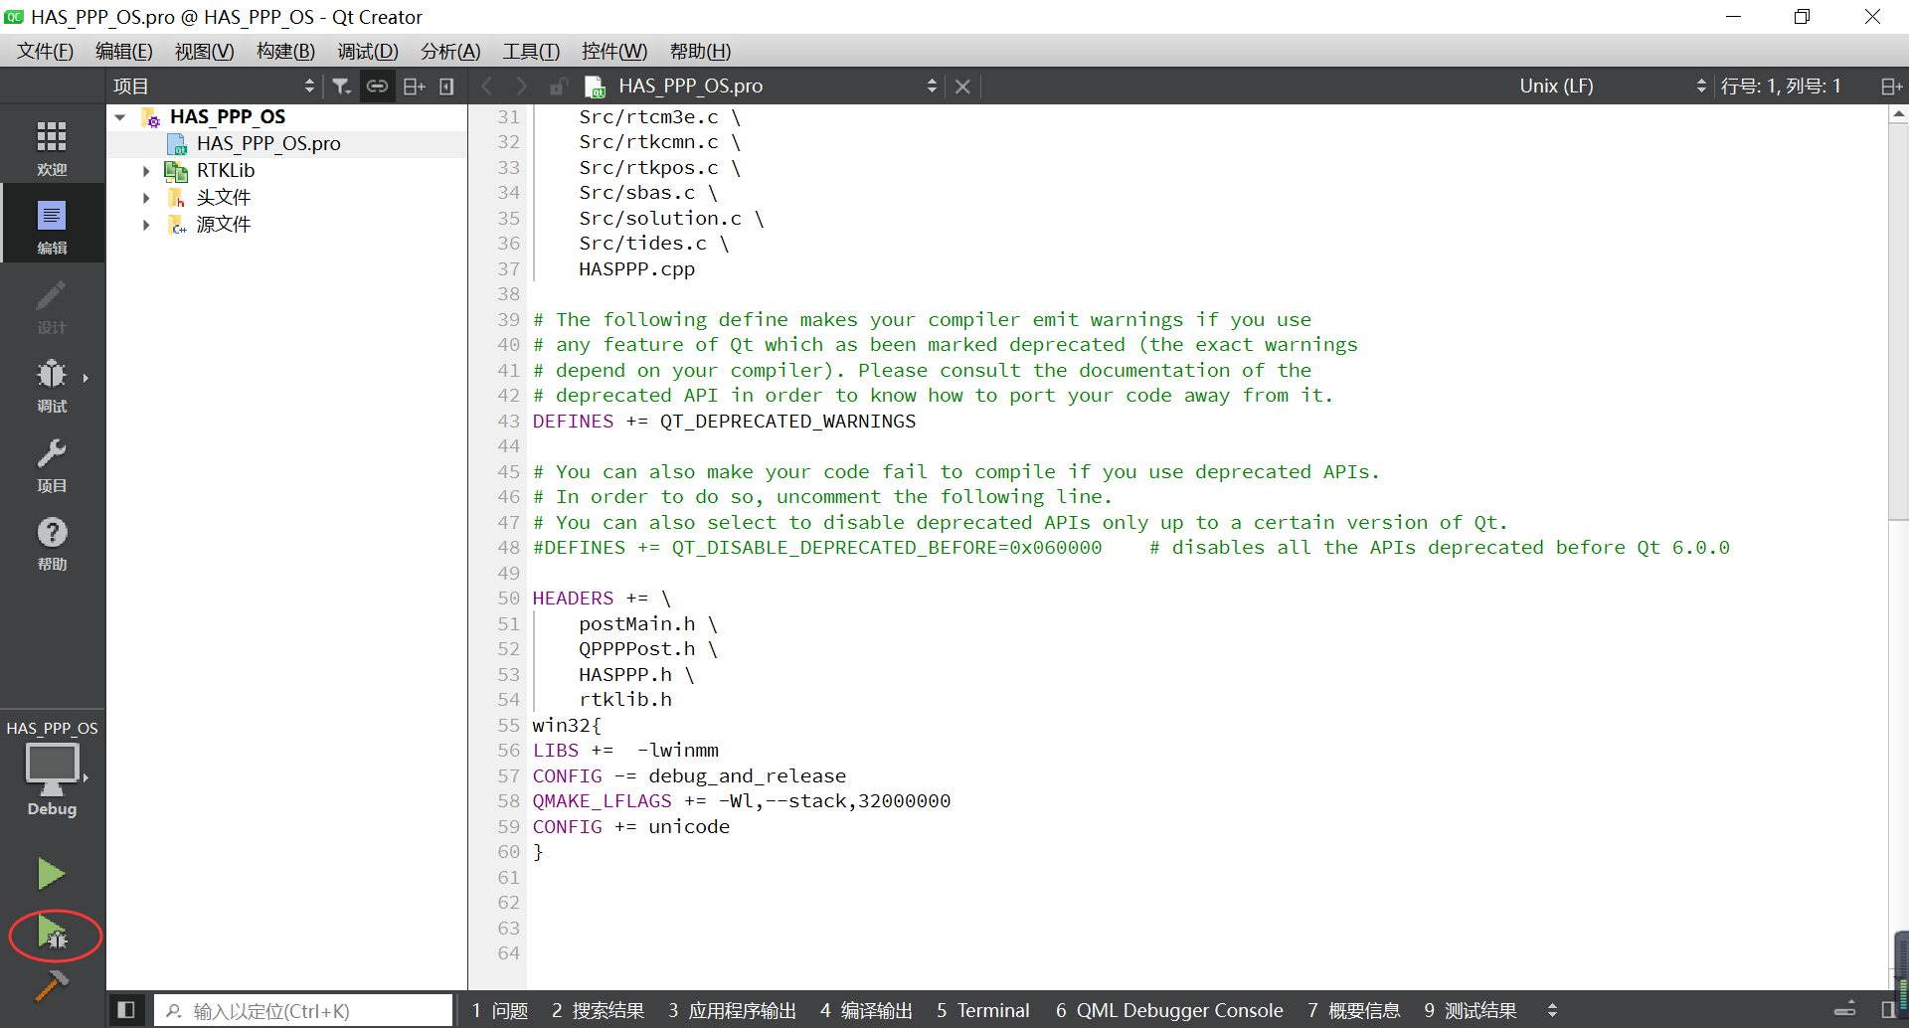

### 4.3.2 Package Executable Program

Users can package the executable program with QT as follow:

1. Run in Release mode in QT creator to generate executable file **HAS_PPP_OS**:



1. Package program

* Windows users (MinGW 5.12.12 64-bit):

**HAS_PPP_OS.exe** should be moved to an “*example/release*” folder. Then “cd” to the folder and “windeployqt” **HAS_PPP_OS.exe** in “*CMD*”.

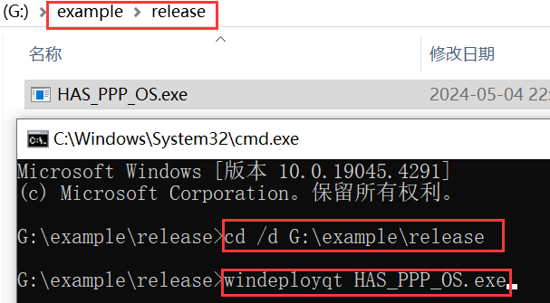

* Linux users (GCC 5.8.0 64-bit):

All the relevant library files must be included, otherwise the program cannot run successfully (Command “*ldd HAS_PPP_OS*” can list all the library files of **HAS_PPP_OS** in “Terminal” for checking), as shown below:

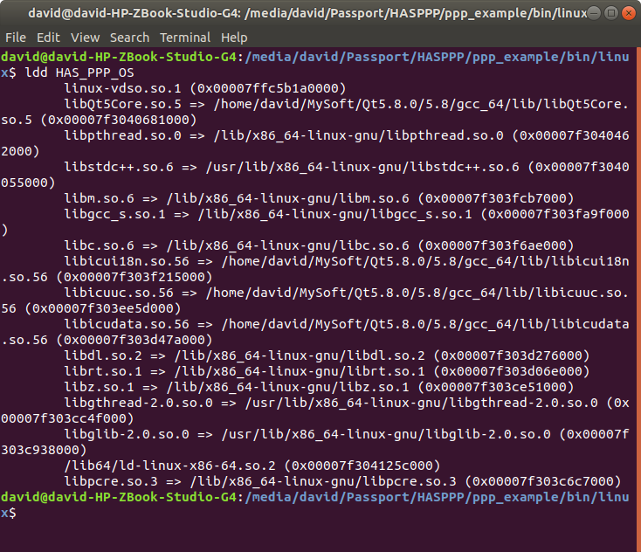

1. Prepare dependencies

Create an empty “*debugFiles*” folder and copy the “*HASPPP\Src\resource*” and “*HASPPP\ppp_example\bin\config*” folders to the same directory as the “*release*” folder, as shown below:

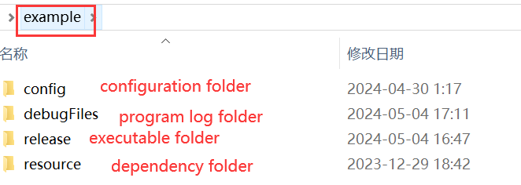

So far, the packaging is complete! **HAS_PPP_OS** in the “*example*” folder can run as demonstrated in Section 3.3.

# 5 Results and Verification

## 5.1 Learning Project for Decoding Official HAS Data

This project is solely aimed at helping users understand the recovery of HAS products from HAS encoded pages. The program execution will generate log messages, as shown below:

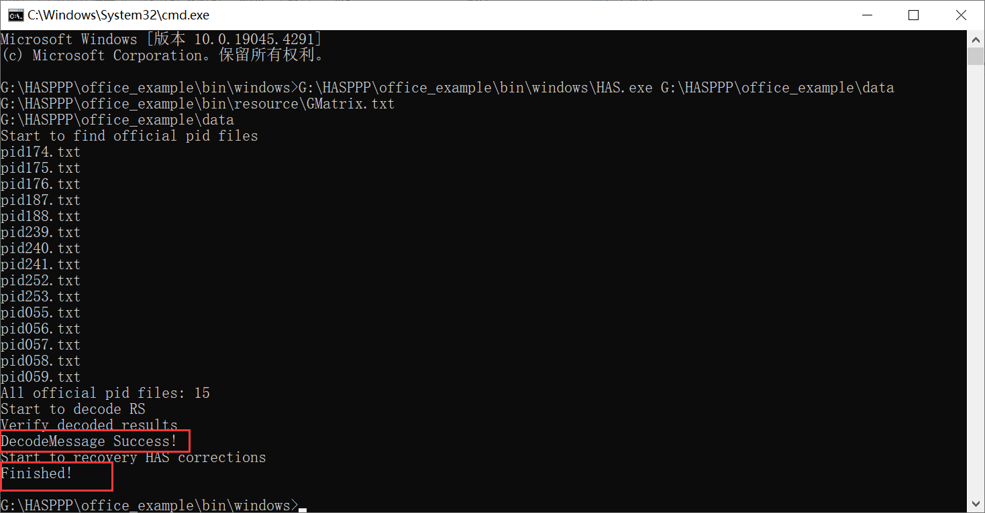

The program will compare the decoded results with the results provided by the official source (“HASPPP\office_example\data\**office_decoded_message.rs**”). If the comparison is successful, it will display “DecodeMessage Success!”.

The recovered corrections (“**SSRA.bnc**”, top) can be compared with the results provided by the official source (bottom):

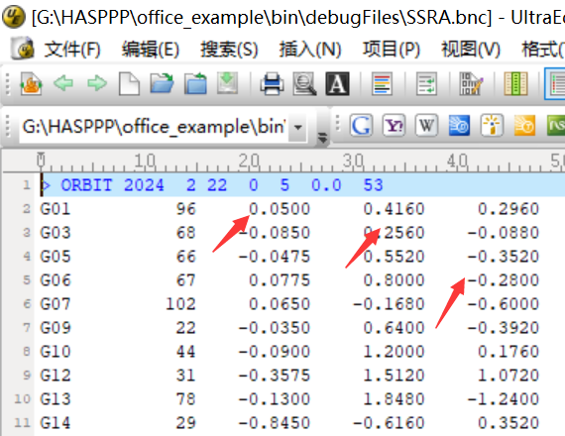

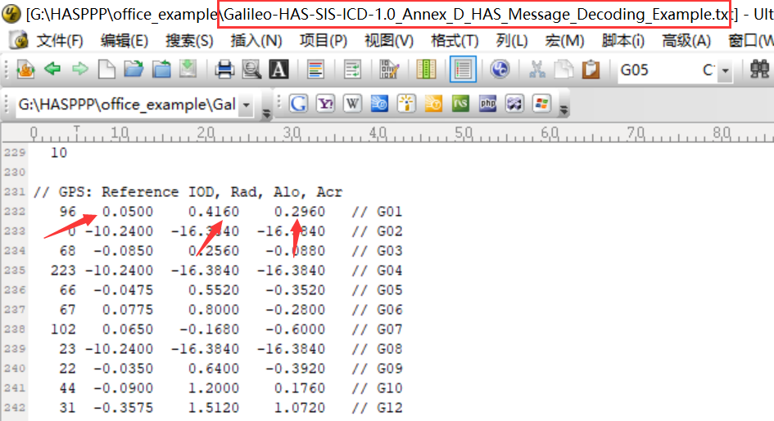

Please refer to Appendix C.3 SSRA.bnc for a detailed description of the log file.

In this case, invoking the HASPPP interface involves the following three steps:

* **Step1-** set working path

*HASPPP HAS (argv[0]);*

*argv[0]* is the executable file of the project.

* **Step2**- read all HAS data

*readpid (filepath, filelists, finPage, n,pid)*

* **Step3***-* invoke the HASPPP decoding interface

*HAS.decodeRs (finPage, pid, n, pageString)*

Invoke the HPVRS decoding function of HASPPP.

*decodePageChange(pageString, n, gpstFrame, &hasSat_i, hasSat_o);*

Invoke the HAS corrections recovery function of HASPPP.

## Learning Project for Decoding Cashed Real-time HAS Data

The program execution will generate log messages, as shown below:

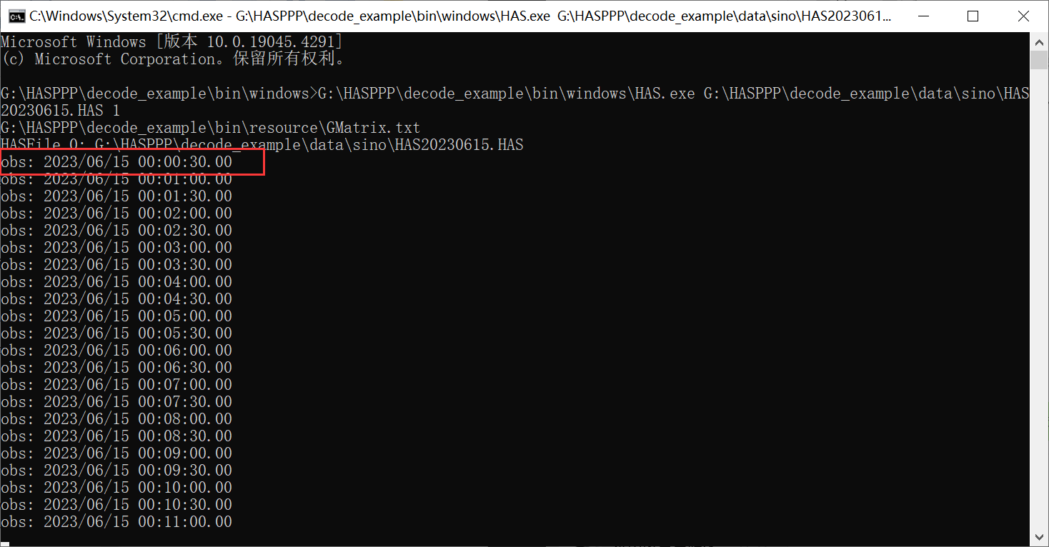

In this case, real-time decoding is simulated, where observations are used to update correction states. Therefore, the terminal displays the timestamps of the observations that have been processed. Additionally, the decoded log (**trace.txt**, **pid.txt**, and **clock.txt**) and result (**SSRA.bnc**) files will be printed to the “*debugFiles*” folder. For detailed information about these files, please refer to Appendix C.

Similar to the program analysis of Case 1, the difference is that in Case 2, real-time data processing is conducted to recover corrections from HAS encoded pages, requiring HPVRS decoding as well. For detailed information, please refer to Appendix B.

The decoding program is invoked in three steps:

* **Step1**- set working path

*HASPPP HAS (argv[0])*

*argv[0]* is the executable file of the project.

* **Step2**- set the path for the HAS files.

*HAS.setHasFile (fileHASlist, atoi(argv[2]))*

*fileHASlist* is the absolute path to the HAS binary files cached by receivers equipped with the HAS receiving module.

*argv[2]* is the corresponding receiver identification. 1, 2 and 3 represent SINO, NovAtel, and Septentrio, respectively.

* **Step3**- invoke the decoding interface of HASPPP

*HAS.updateHasCorrection (obsT)*

*obsT* is the moment of updating the HAS decoding

## PPP Processing Using the RTKLIB Embedded with HASPPP

### Data Preparation

RTKLIB embedded with HASPPP can be used for PPP positioning and time transfer research (Zhang et al. 2024). Currently, HASPPP supports data from three types of receivers, which are stored in separate folders within folder “HASPPP\ppp_example\data”.

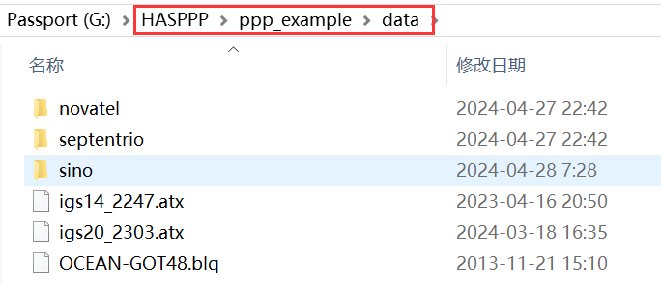

The following will use SINO receivers as a case to introduce PPP processing and its results. PPP input data includes observation files, ephemeris files, and HAS correction files (**\*.HAS**).

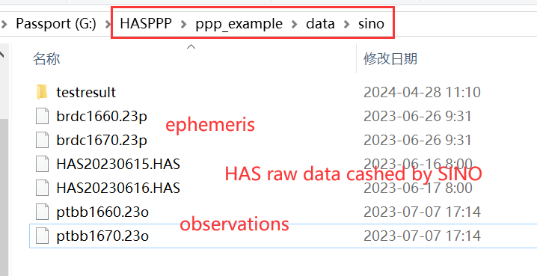

The HAS raw binary data files “**\*.HAS**” and its format are presented in Appendix A.

### Advanced Parameter Configuration

The method to configure PPP input, output, and antenna files through the interface has been explained in section 3.3.1. This section introduces the method of configuring PPP parameters and models through the interface.

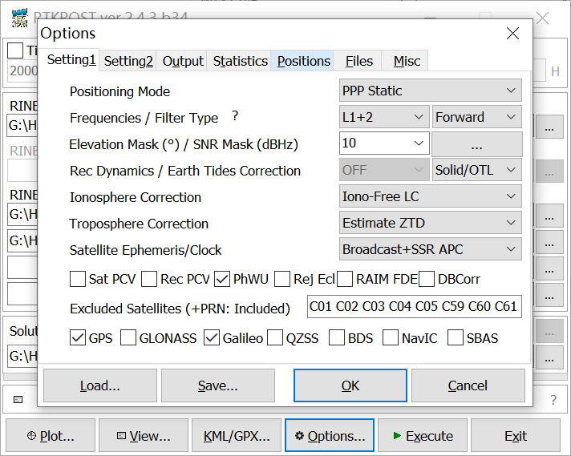

“Positioning Mode”: to select the PPP mode, static (PPP Static) and kinematic (PPP Kinematic);

“Elevation Mask”: to set elevation cutoff angle (unit: degrees);

“Excluded Satellites”: to set satellites to be excluded;

“GPS/Galileo”: to check the satellite systems to participate in PPP.

In addition, parameters and models of tidal corrections (solid/OTL), ionospheric (ionosphere-free combination), tropospheric (model-based corrections and estimation), satellite orbit and clock (ephemeris and HAS corrections), and antenna phase wind-up (model-based corrections) are all fixed and do not require adjustment.

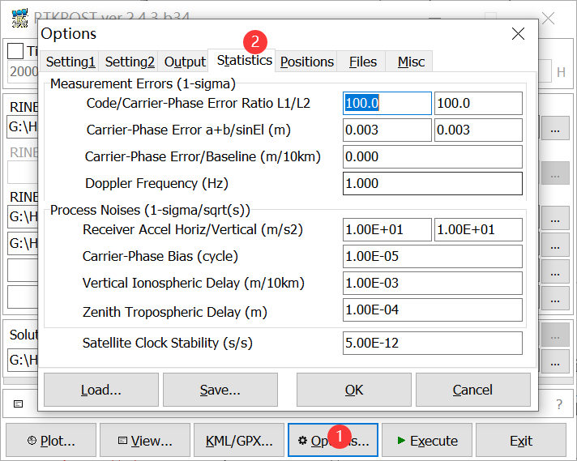

“Carrier Phase Error”: to configure carrier precision;

“Code/Carrier-Phase Error Ratio”: to configure pseudorange precision (100*0.003);

“Carrier-Phase Bias”: to set the process noise for ambiguity parameter estimation;

“Zenith Tropospheric Delay”: to set the process noise for tropospheric parameter estimation.

### Output File Format

1. Positioning result (*.pos)

The storage location for the positioning results can be selected through the interface. For detailed information, please refer to section 3.1.1, Interface Configuration. The **\*.pos** file records the observation epoch (GPST), coordinate results of PPP, PPP status (Q), number of valid satellites (ns), and coordinate variance of PPP.

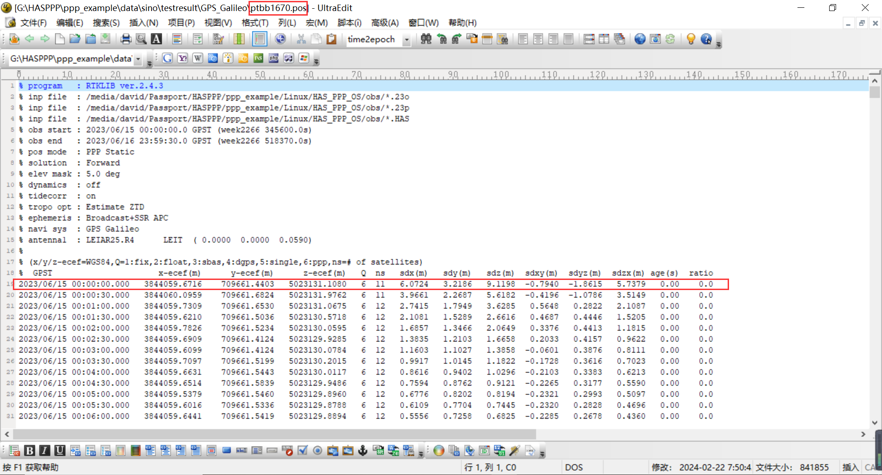

1. State information (*.pos.stat)

The status information file is stored in the same folder as the positioning result file (**\*.pos**). **\*.pos.stat** file records the status information of estimated parameters, such as position, receiver clock offset, tropospheric delay, and ambiguities.

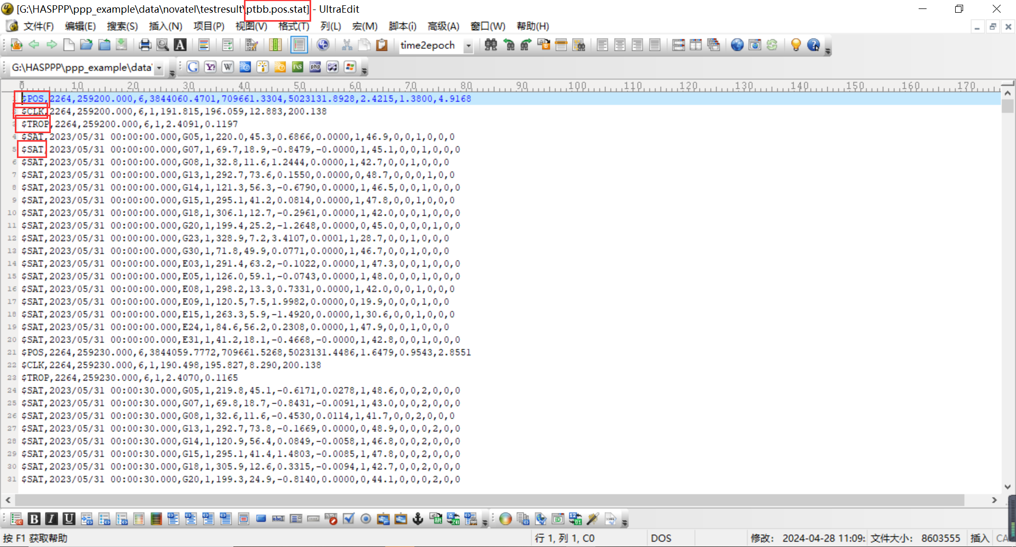

1. Program log file (*.pos.trace)

The program log file is stored in the same folder as the positioning result file (**\*.pos**). **\*.pos.trace** file records log information, including program-specific error messages, status running records, and status information. For example, the estimated receiver clock offset (GPS, GLONASS, Galileo, and BeiDou) in PPP solution can be printed in real-time to the log file, as shown below:

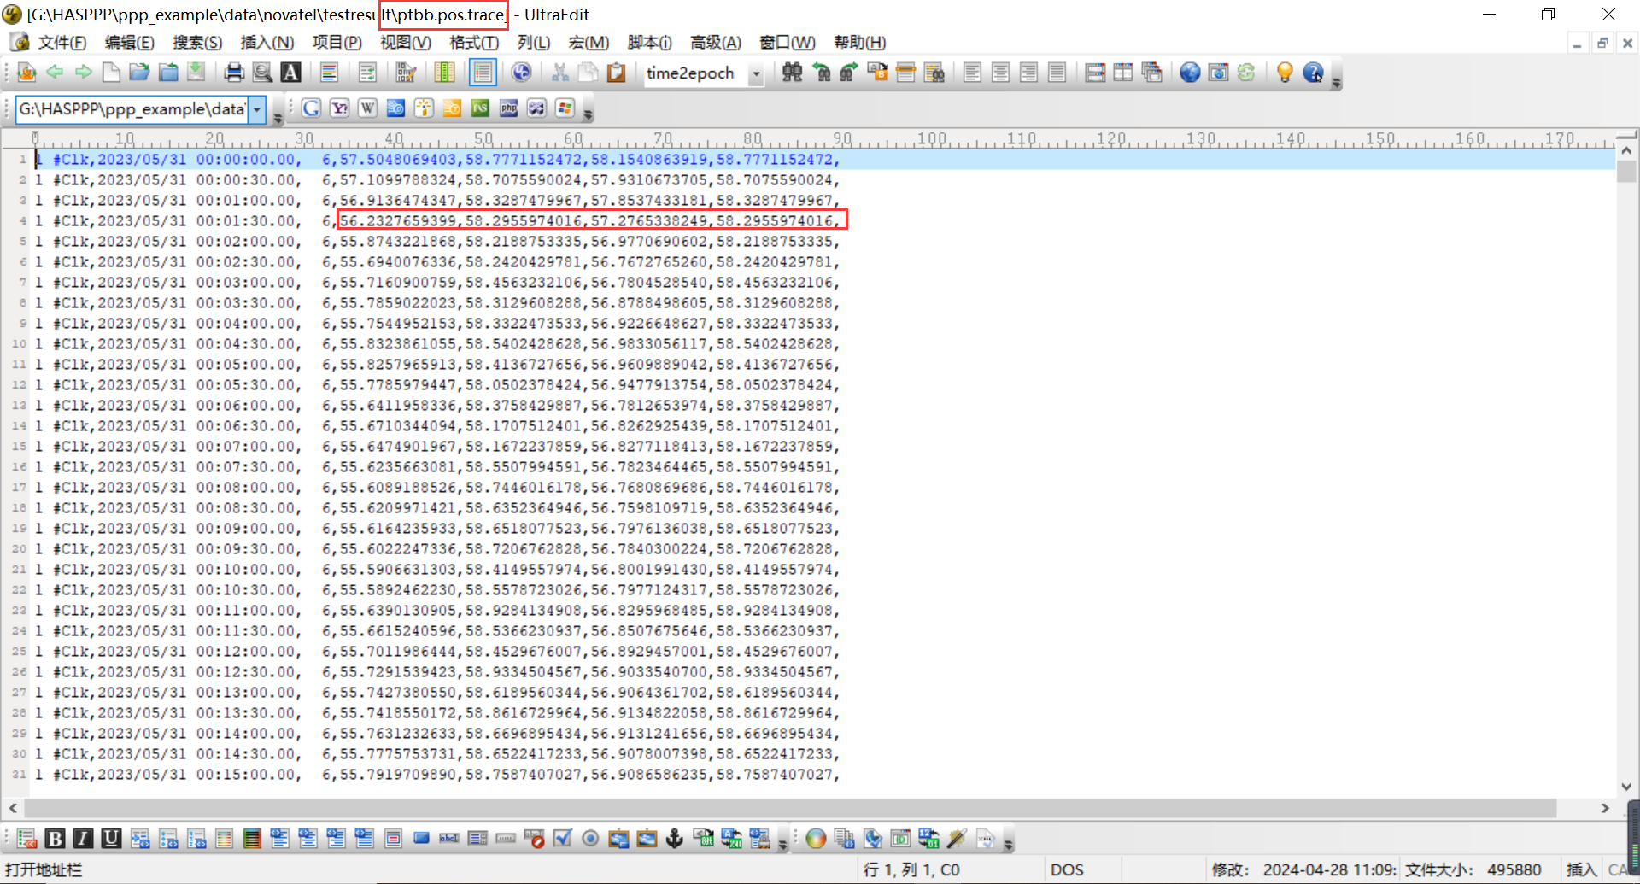

1. HASPPP debug files

All log files (**trace.txt**, **pid.txt**, **SSRA.bnc**, and **clock.txt**) will be output to the “*debugFiles*” folder. For detailed information, please refer to Appendix C.

### Positioning Results

Some MATLAB scripts (plot_NEU.m), which are used to plot the positioning results, are located in “*HASPPP\ppp_example*”, as shown below:

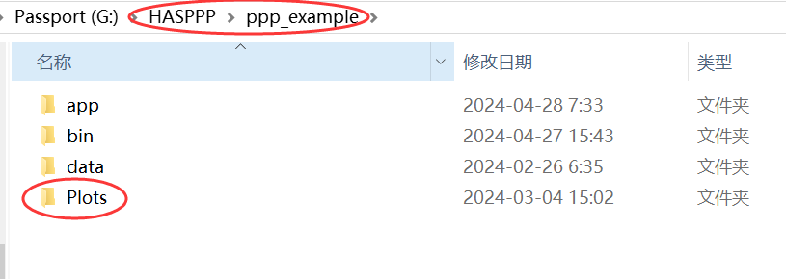

Positioning error sequence (GPS-only, PPP Static):



Positioning error sequence (Galileo-only, PPP Static):



Positioning error sequence (GPS/Galileo, PPP Static):

### PPP Time Comparison Results

A zero-baseline common clock difference (CCD) can be used to depict the noise level of time transfer, which should ideally be constant. the results of the zero-baseline HAS time comparison from the Observatoire de Paris (OP) time-keeping laboratories are shown.



Taking the GBM GPS/Galileo time comparison as a reference, the accuracy of the time comparisons of GPS-only, Galileo-only, and GPS/Galileo using the HAS product was analyzed. The differences between the result sequences of the time comparison using the GFZ rapid Multi-GNSS Experiment (MGEX) product GBM and HAS products are shown. The errors of time comparison fluctuate within ±1 ns.



For additional results, you can refer to the research reports where the authors applied HASPPP to HAS time comparison (Zhang et al. 2024).

# 6 Embedding HASPPP into C/C++ GNSS Software

Details about the decoding process and important considerations are provided in Appendix B. This section only covers the preparation of dependency files for HASPPP and how to integrate it into a C/C++ PPP model.

## 6.1 Preparing Dependency Files

All the source code and dependencies for HASPPP are in folder “*HASPPP\Src*”, as shown below:

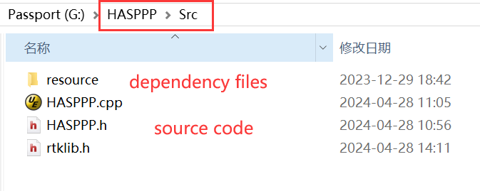

Detailed information about the source code can be found in Appendix B. The dependency files **GMatrix.txt** (systematic generator matrix) and **HASInv.txt** (multiplication table of Galois field (GF) field of order 256) were all generated using MATLAB scripts, as shown below:

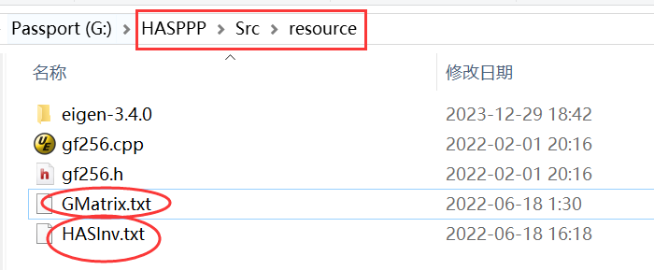

The MATLB scripts that generate the dependency files are placed in the “HASPPP\Matlab” folder, as shown below:

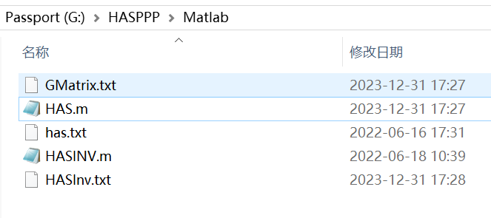

**has.txt** stores the coefficients of the generator polynomial, which can be obtained from the HAS ICD (EUSPA 2022). The coefficients in the ICD are as follows:

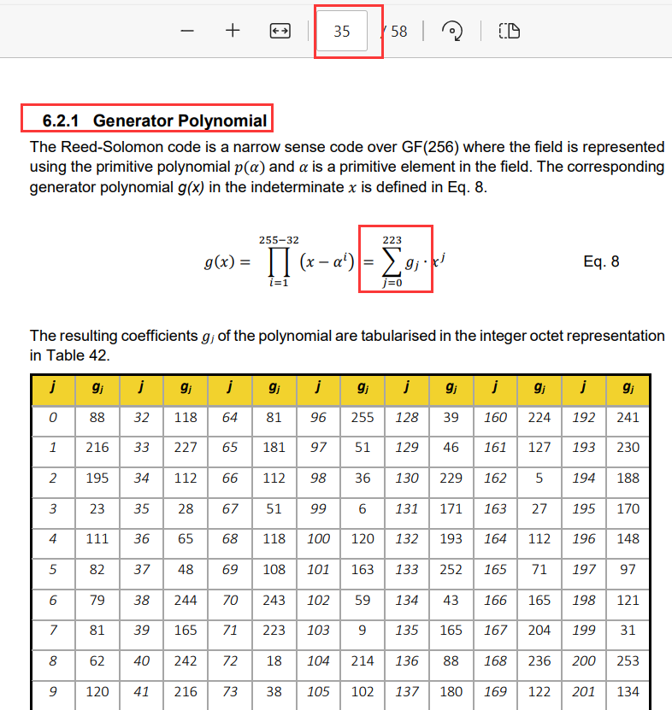

Therefore, the coefficient matrix corresponding to the HAS ICD can be generated using **HAS.m** and is represented in **GMatrix.txt**. The contents of the coefficient matrix corresponding to the ICD in **GMatrix.txt** are as follows:

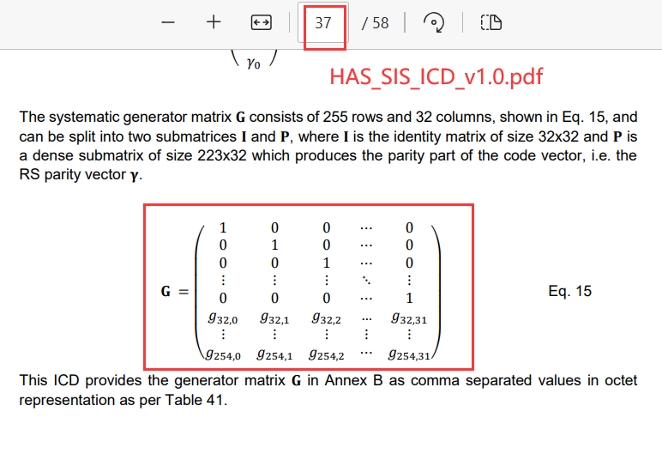

HPVRS decoding requires inversion in GF(256), and HASPPP utilizes table lookup methods for GF(256) inversion. **HASInv.txt** generated by **HASINV.m** contains the multiplication table for GF(256).

## 6.2 Working Directory

**GMatrix.txt** and **HASInv.txt**, as HASPPP dependency files, need to be read and initialized. Additionally, HASPPP automatically outputs its log files to the “*debugFiles*” folder. Therefore, it is necessary to set the working directory of HASPPP. The working directory is obtained through input parameter in the constructor function of HASPPP. The input parameter is the absolute path of the project executable file (Note: relative paths are not supported).

The steps to set the working directory are as follows:

1. Check the location of folders “*Debug*”, “*debugFiles*”, and “*resource*”

All three folders are essential, and their correct relative locations are as follows:

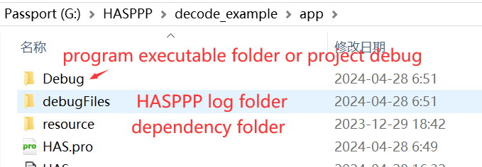

The “*Debug*” folder is the debugging directory for PPP or decoding projects, containing the executable files generated by the project (such as files ending with **\*.exe** on Windows).

1. Initialize the HASPPP object with the absolute path of the executable file.

Pass the absolute path of the executable file as a parameter to the constructor of the HASPPP object, as shown below:

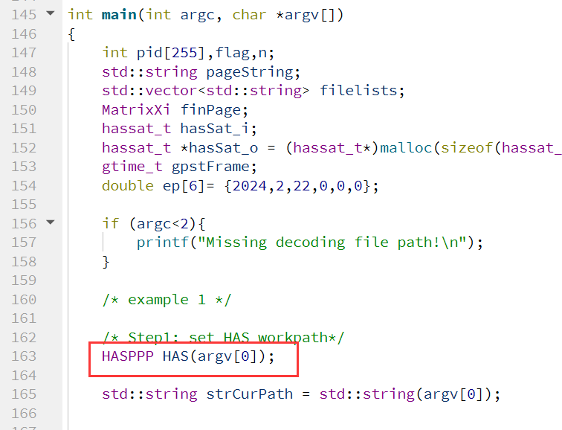

Check if variables *m_gPath* and *m_hasInvPath* have correctly read the absolute paths of the dependency files, as shown below:

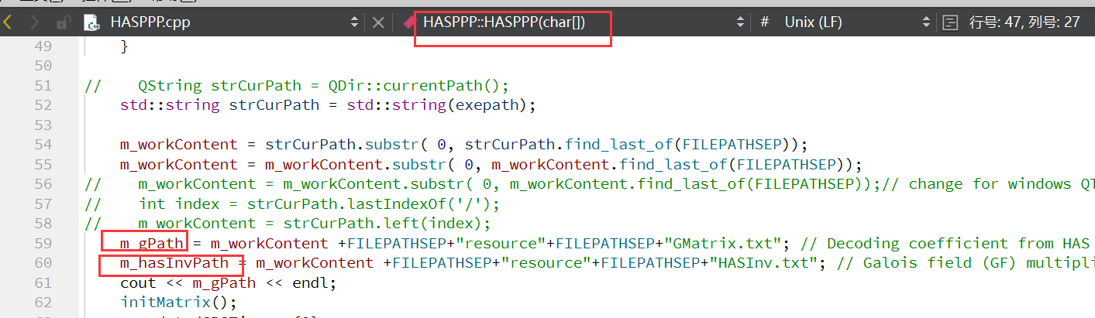

## 6.3 Embedding Details

The interface functions provided by HASPPP to C/C++ GNSS software are outlined below:

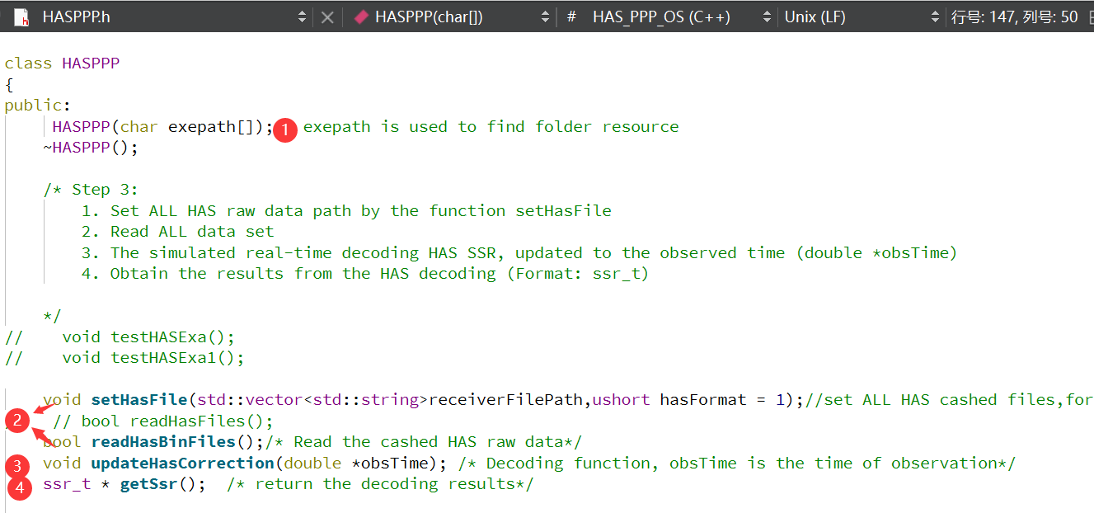

The usage of decoding interface functions involves four steps:

* **Step 1**- set the working directory for HASPPP:

*HASPPP (char exepath[])*

The working directory is set through the constructor of HASPPP. The parameter *char exepath []* is the absolute path to the executable file of the project.

* **Step 2**- set up the HAS binary files to be processed and read these files:

*void setHasFile (std::vector<std::string>receiverFilePath, ushort hasFormat = 1)*

The parameter *receiverFilePath* represents the absolute path of all HAS binary files, while *hasFormat* represents the format used by receiver manufacturers. The *hasFormat* option offsets only three choices: China SINO, NovAtel, and Septentrio, corresponding to inputs 1, 2, and 3, respectively.

*bool readHasBinFiles();*

The function does not accept any input parameters. Its function is to read data from the input HAS file.

* **Step 3**- update the status of HAS corrections in real-time as epochs progress.

*void updateHasCorrection (double *obsTime)*

The input parameter *obsTime* is a six-element array representing the timestamp of the observation moment (year, month, day, hour, minute, second). This function operates by processing the HAS binary byte by byte, simulating real-time decoding of HAS products. It updates the state of HAS and synchronizes the status of HAS corrections with the timestamp of the input observation moment *obsTime*.

* **Step 4**- retrieve HAS corrections:

*ssr_t * getSsr ()*

The function is capable of returning the updated status of HAS corrections aligned with the timestamp of the observation moment. The status output is obtained in the form of the *ssr_t* structure within the RTKLIB framework. For integration with other GNSS software, users are required to establish an interface from *ssr_t* to the respective GNSS software. This structure has been applied in both real-time and post-processing PPP calculations and can also be used to generate products in RTCM format.

|  |  |
| --- | --- |
|  |  |
|  |  |

# Appendix

## Receiver Configuration and Its HAS Data Format

Raw HAS data needs to be obtained through GNSS receivers and cannot be acquired from IGS/IGMAS data centers. Currently, the HAS decoder HASPPP supports raw HAS binary data from three different receiver manufacturers: China SINO, Septentrio, and NovAtel. Data collection and layout will be further elaborated. We also provide [online HAS datasets](https://github.com/ZhangRunzhi20/High-Accuracy-Service-public-dataset) via GitHub.

### A.1 China SINO

1. Data output configuration command:

|  |  |
| --- | --- |
| unlogall  log hasmess ontime 1  saveconfig | // Disable all message outputs;  // The HAS output interval is set to 1 second;  // Save configuration to boot. |

2. SINO HAS data format:

**Table 1** illustrates the structure of HAS data frames output by properly configured SINO receivers, with the output order arranged according to the keywords in the table. “Message Header” represents the defined data header output by China SINO receivers, and “HAS Page” represents the cached raw binary data from Galileo C/NAV. The specific data layout of “Message Header” and “HAS Page” are detailed in **Fig.1** and HAS ICD (EUSPA 2022) respectively.

**Table 1** Data frame structure output by SINO receivers (unit: bit)

|  |  |  |  |
| --- | --- | --- | --- |
| Message Header | Reserved | HAS Page | CRC |
| 224 | 2 | 512 | 32 |

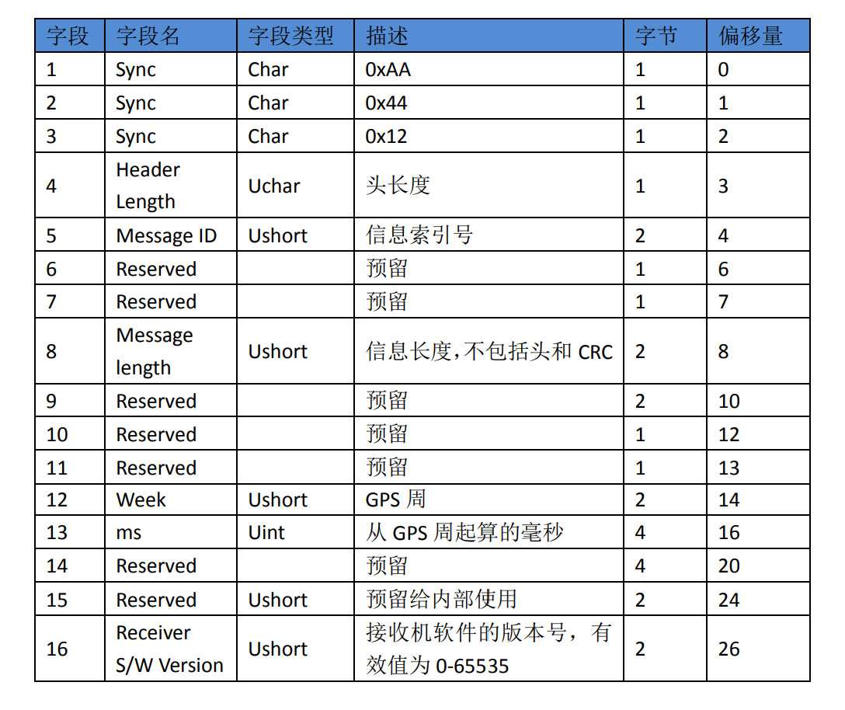

**Fig. 1** SINO message header

3. Real-time Online Streaming of HAS Data:

We have established a networked transport of RTCM via internet protocol (NTRIP) Caster, through which real-time HAS data streams from a SINO receiver are pushed to the public NTRIP Caster. Users can access real-time raw HAS data frames output by SINO receivers using an NTRIP Client.

It is worth noting that this differs from Galileo broadcasting HAS data in RTCM format over the Internet. Its purpose is to facilitate more researchers in testing the HASPPP.

**Fig. 2** depicts the configuration of receiving NTRIP data using the STRSVR plugin in RTKLIB. Below is the account currently in use:

NTRIP Caster Address: 42.51.39.39;

Port: 20198;

Mountpoint: HAS;

User ID: has;

Password: 99.

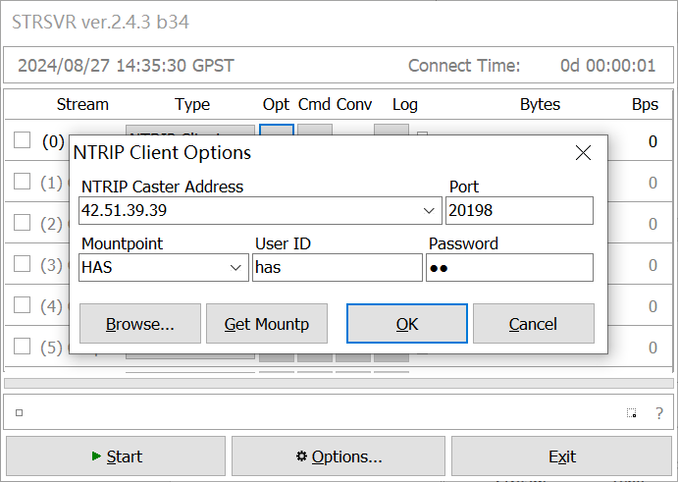

**Fig. 2** Receiving NTRIP data via the STRSVR plugin

### A.2 Septentrio

Septentrio receivers are recommended to be configured using its interface configuration tool, [RxTools](https://www.septentrio.com/en/products/gps-gnss-receiver-software/rxtools#resources).

The HAS data frames output by Septentrio receivers are displayed in **Fig. 3**. The HAS message ID output by Septentrio receivers is 4024, where “NAVBits” denotes the raw HAS binary data cached by Septentrio receivers in real-time. For more comprehensive information regarding Septentrio receivers output, please consult the [Septentrio receiver manual](https://www.septentrio.com/en/products/gps/gnss-receiver-modules/mosaic-t).

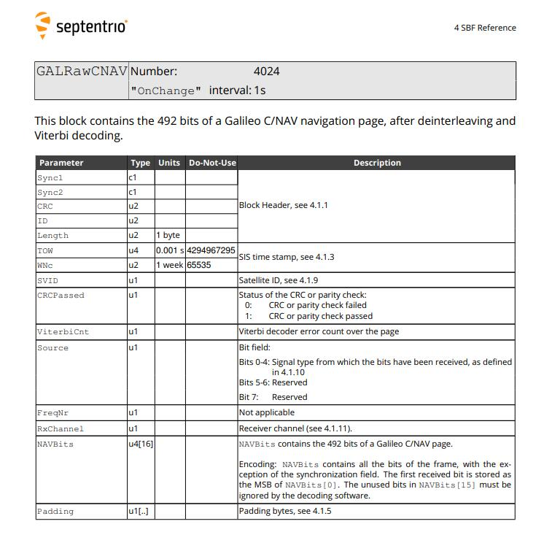

**Fig. 3** Structure of the HAS data frame output by Septentrio receivers

### A.3 NovAtel

1. Data output configuration command:

|  |  |
| --- | --- |
| unlogall  log galcnavrawpage onnew  saveconfig | // Disable all message outputs;  // Output HAS binary data;  // Save configuration to boot. |

2. NovAtel HAS data format:

The HAS data frames output by the NovAtel OEM729 are illustrated in **Fig. 4**. The HAS message ID output by NovAtel OEM729 is 2239, with “data” denoting the raw HAS binary data cached by the receiver in real-time. For additional information regarding NovAtel OEM729 output, please consult the [NovAtel OEM729 receiver manual](https://docs.novatel.com/OEM7/Content/PDFs/OEM7_Commands_Logs_Manual.pdf).

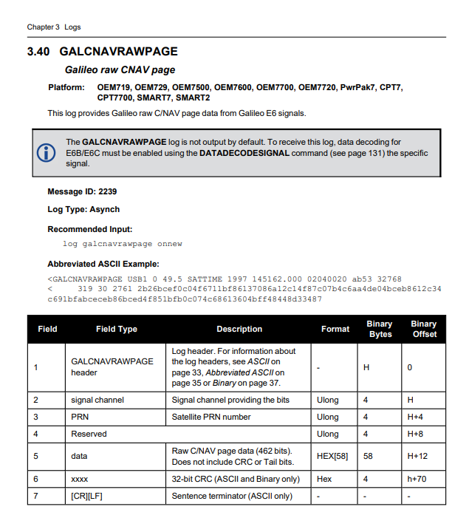

**Fig. 4** Structure of the HAS data frame output by the NovAtel OEM729 receiver

## HASPPP Core Code Framework

The main content is divided into two parts: the first part encompasses HAS data frames (HAS pages) and their reception processing, while the second part centers on the core code. Regarding the introduction to HAS pages, the authors have primarily included their interpretations and additional content beyond what is specified in the HAS ICD.

### B.1 Introduction to HAS Pages

HAS corrections are broadcast via the C/NAV navigation message of the Galileo E6-B signal component. The symbol rate of the C/NAV navigation message is 1000. The HAS product is organized into HAS encoded pages, which are then encoded into the actual C/NAV navigation message using forward error correction (FEC) convolutional encoding. **Fig. 5** shows the page layout of the Galileo HAS. A Galileo HAS page consists of 24 bits HAS page head and 424 bits page body. HASS (HAS status) represents whether the HAS data is available, primarily including “Test mode”, “Operational mode”, and “Don't use”. The message type (MT), currently only contains message type 1, referred to as MT1.



**Fig. 5** Page layout of the Galileo HAS

A complete HAS message (MT1) is designed with various combinations. Currently, there are two main combinations for receiving the precise HAS product: “MT1 with mask, orbit corrections, code biases (MT1-slow)” and “MT1 with clock full-set correction (MT1-fast)” (EUSPA 2022). The MT1 is encoded into N=255 HAS encoded pages C1, …, CN by HPVRS, and then distributed to different Galileo satellites for dissemination. Each encoded page occupies 424 bits (53 bytes or hexadecimal symbols). The fragmented HAS encoded pages are received by combining the MID (ID of message), MS (size of message), and PID (ID of transmitted HAS encoded page) keywords. The purpose of performing HPVRS is that the user only needs to receive MS plus 1 encoded pages Ci with the same MID and decodes these to obtain the original HAS message in the GF domain by using the PIDs.

The layout of MT message after HPVRS decoding is shown in the **Fig. 6**. The length of MT message is not fixed and is currently mainly divided into two types, namely MT1-slow and MT1-fast. The distinction between the two types of messages is made through the MT1 header.



**Fig. 6** MT message

Time of hour (TOH) represents the time (Galileo system time, GST) for this particular message. TOH, in conjunction with the validity interval keyword in each message, determines the validity time of the HAS product. The HAS product comprises six types of messages, namely Mask, Orbit Corrections, Clock Full-Set Corrections, Clock Subset Corrections, Code Biases, and Phase Biases. The presence of each piece of information in the MT message is identified through the “Block Flag”, indirectly determining the length of the MT message. Currently, MT1-slow (MT1 with mask, orbit corrections, code biases) and MT-fast (MT1 with clock full-set correction) have been established. The specific details of each keyword can be obtained through the HAS ICD (EUSPA 2022).

The Galileo HAS satellite orbit, clock, and code biases products can be obtained by combining MT1-slow and MT1-fast using the ID of mask (Mask ID) and the ID of reference set of IODS (IOD Set ID). Real-time precise orbit and clock recovery are achieved by applying HAS corrections to the ephemeris. The link between the HAS corrections and ephemeris is established through IOD Ref and IODnav of Galileo I/NAV or IOD Ephemeris (IODE) of GPS LNAV. This process is illustrated in **Fig. 7**.



**Fig. 7** HAS message combination

### B.2 Introduction to HAS Decoding and the HASPPP Program

The HPVRS enhances the efficiency of HAS message reception, yet attention must be given to the following issues to ensure successful decoding of HAS messages:

1) Currently, the two combinations of MT1 are broadcast alternately, and the receiving handler needs to set the encoded pages cache to continue receiving the MT1-slow after the MT1-fast ends.

2) The value of MS in MT1-fast is very flexible. When MT1-fast contains only Galileo or GPS satellite clock offset corrections, the value of MS is 0, and when both are included, the value of MS is 1. The handler needs to ensure that these two MT1-fast cases are not missed.

3) During the receiving process of MS plus 1 encoded pages, the same PID encoded pages may be received, and such encoded page must be ignored.

FEC decoding is ignored because the C/NAV navigation message output by GNSS receivers has already been decoded. The core decoding process of HAS in the HASPPP is illustrated in **Fig. 8**, with the input being a 492-bit C/NAV data frame. HASS, MT, and PID in HAS encoded page header are obtained. The HAS encoded pages that can be decoded has both HASS and MT equal to 1. In the HAS encoded page header, three keywords correspond to the features of each HAS encoded page: MID, MS, and PID, necessary for restoring the complete MT1. Therefore, it is essential to search for a sufficient number of HAS encoded pages based on these three keywords for HPVRS decoding.



**Fig. 8** HASPPP decoding process

When searching for HAS encoded pages, because there are two MT1 messages that can be received, each with a different MID, and they are alternately broadcasted by Galileo satellites, two HAS decoding buffers are required. The buffer is a structure that stores MID, PID, HAS encoded pages, and the number of cached PIDs, denoted as “n_pid”. The process of searching for all HAS encoded pages is as follows:

* **Step1**- to determine whether they belong to the same group of HAS encoded pages, compare their MID with “MID1” in “buffer1”. If they belong to the same group, cache the PID, HAS encoded page, and increment the “n_pid” count;
* **Step2**- to determine if all HAS encoded pages have been received by checking MS; Once a complete set of HAS encoded pages with different PID values has been received, sort the HAS encoded pages and PID array based on PID values;
* **Step3**- to send the sorted HAS encoded pages and PID array to HPVRS decoding; “buffer1” clear; Next process start.

If the MID matches that in “buffer2” for a group of HAS encoded pages, swap “buffer1” and “buffer2”. Next is the decoding of HPVRS in the GF domain and the calculation of HAS corrections. These GF domain decoding and product recovery processes can be found in the HAS ICD (EUSPA 2022).

The specific corresponding functions in HASPPP are as follows:

* *void updateHasCorrection (double * obsTime)-* the input parameter *obsTime* is a six-element array representing the timestamp of the observation moment (year, month, day, hour, minute, second). Within this function, the HAS binary is processed byte by byte, simulating real-time decoding of HAS products. The state of HAS is updated, and the status of HAS corrections is updated to the timestamp of the input observation moment *obsTime*.
* *int decodeSINOHead (uint8_t navCharSina[64], gtime_t *gpstFrame, int &readOffset)-* obtain C/NAV message frames (492 bits) from the output of the SINO receiver.
* *int decodeNovAtelHead (uint8_t navCharSina[64], gtime_t *gpstFrame, int &readOffset)-* obtain C/NAV message frames (492 bits) from the output of the NovAtel receiver.
* *int decodeSeptentrioHead (uint8_t navCharSina[64], gtime_t *gpstFrame, int &readOffset)-* obtain C/NAV message frames (492 bits) from the output of the Septentrio receiver.
* *void processCNAV (uint8_t *dataUChar, gtime_t gpstFrame)-* the core processing function of HAS decoding, where input parameter *dataUChar* represents C/NAV data frames, remains consistent across the three receiver manufacturers. To facilitate understanding of the code, **Fig. 8** can be referenced for comparison.
* *void decodeRs (MatrixXi pageIn, int *pid, int pidLen, std::string& OutString)-* this function completes the HPVRS decoding, where *pageIn* is a set of complete HAS encoded pages, *pid* is a set of complete PIDs, *pidLen* is the number of PIDs, and *OutString* is the decoding result.
* *void MatrixInv (MatrixXi matrixIn, MatrixXi &matrixOut)-* this function completes the operation of matrix inversion in the GF using the table lookup method.
* *bool decodePageChange (std::string page, int pidLen, gtime_t gpstTime, hassat_t * hasSat_i, hassat_t * hasSat_o)-* this function completes the recovery of HAS corrections, utilizing the output *page* from HPVRS decoding. As HAS corrections are state corrections, both MT-slow and MT-fast processes need to complete matching. Therefore, input state structures *hasSat_i* and output structures *hasSat_o* are required.
* *bool decodeMask (uint8_t *buffer, hassat_t &hasSat, int *indexF)-* this function completes the decoding of HAS Mask blocks.
* *bool decodeOrbit (uint8_t *buffer, hassat_t &hasSat, int *indexF)-* this function completes the decoding of HAS Orbit Corrections blocks.
* *bool decodeCF (uint8_t *buffer, hassat_t &hasSat, int *indexF)-* this function completes the decoding of HAS Clock Full-Set Corrections blocks.
* *bool decodeCS (uint8_t *buffer, hassat_t &hasSat, int *indexF)-* this function completes the decoding of HAS Clock Subset Corrections blocks.
* *bool decodeCodeBias (uint8_t *buffer, hassat_t &hasSat, int *indexF)-* this function completes the decoding of HAS Code Biases blocks.
* *bool decodePhaseBias (uint8_t *buffer, hassat_t &hasSat, int *indexF)-* this function completes the decoding of HAS Phase Biases blocks.

## Log Files of HASPPP Decoding Package

Log files serve as a valuable tool for troubleshooting issues, understanding system behavior, and auditing performance. When decoding HAS data, HASPPP provides detailed intermediate result logs in the form of files. All these log files are located within the “*debugFiles***”** folder. Next, we will introduce the content of each log file in sequence.

### C.1 trace.txt

The **trace.txt** file contains important milestone information during the decoding process of HASPPP, including monitoring of input data and detection of fatal errors occurring during program decoding. To enable this log, users need to define the keyword **TRACEHAS**, and the program will automatically match the output path of **trace.txt**.

Function declaration:

*void traces (int tracelevel, gtime_t gpstime, std::string ErrorMsg);*

By invoking function *traces*, users can augment the program with additional log output. “tracelevel” is the importance level of logging message information. The most critical information is assigned a priority level of “1”, while the least critical information is assigned a priority level of “5”, at the user’s discretion. “gpstime” is the timestamp of this message. “ErrorMsg” is the content of the log message.

### C.2 pid.txt

The**pid.txt** file contains the HPVRS decoding output in hexadecimal character form. If **TRACEPID** is defined, binary MT message frames will be output during the HASPPP decoding process.

An example of **pid.txt** is shown in **Fig. 9**. Each HPVRS decoding output consists of two lines, starting with “time:” and “page:” respectively.

Firstly, “time:” is a timestamp indicating the completion time of a set of HAS encoded pages collection, derived from the header file output by GNSS receivers. Following this is the MID and MS values of this group of HAS encoded pages, as well as the number of PIDs (n_pid) during HPVRS decoding. The value of “n_pid” should be MS plus 1, and at the end of this line are all the PID values of this group of HAS encoded pages.

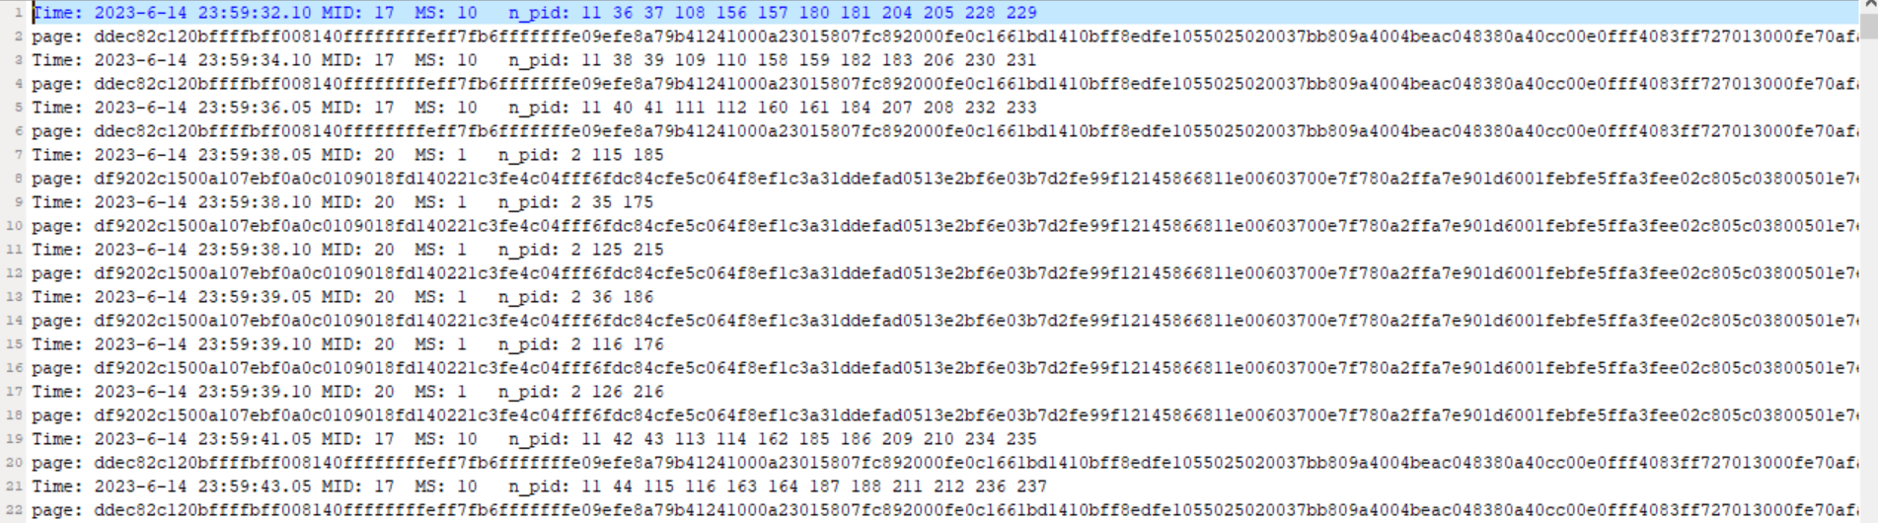

**Fig. 9** HPVRS decoding results in **pid.txt**

The line starting with “page:” contains the HPVRS decoding result of this group of HAS encoded pages. There are two interesting findings: The first is that the pages on lines 2, 4, 6, 20, etc., are consistent. Their MIDs are the same; only they are encoded into different pid data by HPVRS. The advantage of HPVRS: only collect the same set of encoding results of the specified number of encoded pages, the results obtained by HPVRS decoding is the same.

In the second point, the two lengths of MS are broadcasted alternately, and decoding reveals that the longer MS is MT-slow while the shorter one is MT-fast.

### C.3 SSRA.bnc

If **TRACEBNC** is defined, HAS corrections results will be output in **SSRA.bnc**. The output results are consistent with the real-time product files cached by BKG’s BNC software.

HAS decoding results are output in the **SSRA.bnc** file, with an output format consistent with BKG’s BNC GNSS software. The only difference lies in the addition of the observation time at the beginning of each entry, labeled as “obsTime:” to facilitate debugging of the HASPPP output results. MG-APP (Xiao et al. 2020) supports the use of BNC output results for data processing and positioning, making this mode valuable as well.

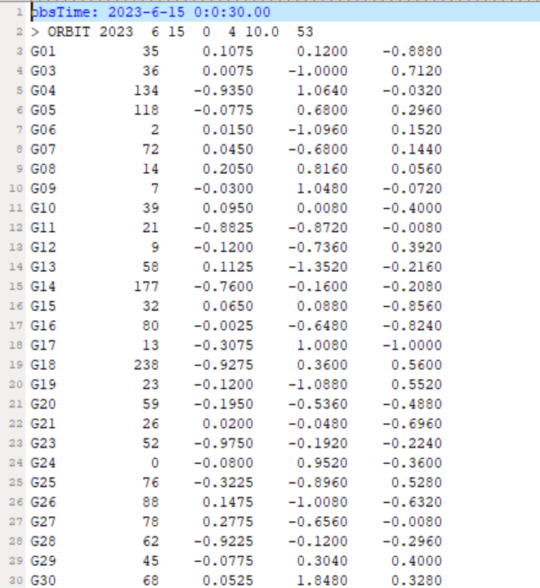

**Fig. 10** HAS corrections recovery results in **SSRA.bnc**

### C.4 clock.txt

If **TRACECLOCK** is defined, valid time of HAS clock corrections will be output in **clock.txt** during HASPPP decoding process. The HAS clock corrections are frequently updated. Through this file, you can find the valid time of all satellite clock corrections in PPP.

The update rate of HAS clock offset corrections is relatively fast, making it prone to errors. Whenever HASPPP recovers HAS clock offset corrections, it will output the update time, validity time, and its values.

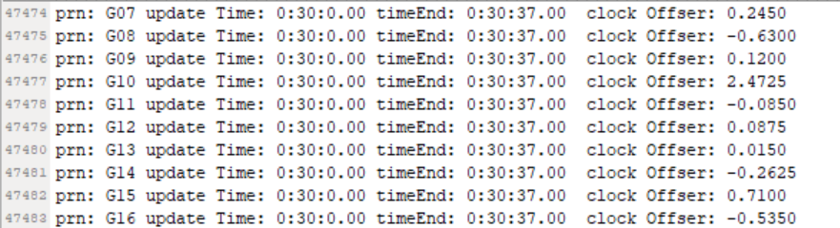

**Fig. 11** Valid time of HAS clock corrections in **clock.txt**

# References

Borio D, Susi M, Gioia C (2023) GHASP: a Galileo HAS parser. GPS Solutions 27(4):197. https://doi.org/10.1007/s10291-023-01529-y.

de Blas FJ, Vázquez J, Hernández C, Ostolaza J, Lagrasta S, Fernandez-Hernández I, Blonski D (2023) The Galileo High Accuracy Service (HAS): A Pioneer Free-of-Charge Global Precise Positioning Service. ION GNSS 2023, Institute of Navigation, Denver, Colorado, UAS, September 11-15, pp. 449-468. <https://doi.org/10.33012/2023.19197>.

EUSPA (2022) Galileo high accuracy service signal-in space interface control document (HAS SIS ICD), issue 1.0. <https://www.gsc-europa.eu/sites/default/files/sites/all/files/Galileo_HAS_SIS_ICD_v1.0.pdf>.

EUSPA (2023a) Galileo High Accuracy Service goes live! https://www.euspa.europa.eu/newsroom/news/galileo-high-accuracy-service-now-operational.

EUSPA (2023b) Galileo high accuracy service service definition document (HAS SDD), issue 1.0. <https://www.gsc-europa.eu/sites/default/files/sites/all/files/Galileo-HAS-SDD_v1.0.pdf>.

Fernandez-Hernandez I et al (2022) Galileo high accuracy service: initial definition and performance. GPS Solutions 26(3):65. <https://doi.org/10.1007/s10291-022-01247-x>.

Horst O, Kirkko-Jaakkola M, Malkamäki T, Kaasalainen S, Fernández-Hernández I, Moreno AC, Díaz SC (2022). HASlib: an open-source decoder for the galileo high accuracy service. In: Proceedings of the ION GNSS 2022, Institute of Navigation, Denver, Colorado, USA, September 19–23, pp 2625–2633.

Naciri N, Yi D, Bisnath S, De Blas FJ, Capua R (2023) Assessment of Galileo High Accuracy Service (HAS) test signals and preliminary positioning performance. GPS Solutions 27(2):73. <https://doi.org/10.1007/s10291-023-01410-y>.

Parra C, Schütz A, Pany T, Hugentobler U, Baumann S (2023) The Galileo High Accuracy Service: Assessment of the Quality of Corrections and Preliminary PPP Performance. ION GNSS 2023, Institute of Navigation, Denver, Colorado, UAS, September 11-15, pp. 2581-2591. <https://doi.org/10.33012/2023.19221>.

Takasu T, Yasuda A (2009) Development of the low-cost RTK-GPS receiver with an open source program package RTKLIB. International symposium on GPS/GNSS, International Symposium on GPS/GNSS. Korea, November 4-6.

Xiao G, Liu G, Ou J, Liu G, Wang S, Guo A (2020) MG-APP: an open-source software for multi-GNSS precise point positioning and application analysis. GPS Solutions 24(3):66. https://doi.org/ 10.1007/s10291-020-00976-1.

Yi D, Bisnath S, Naciri N, de Blas FJ, Capua R (2023) Performance Assessment of Galileo High Accuracy Service (HAS) with Low-Cost GNSS/IMU Sensors in Urban Driving Environments. ION GNSS 2023, Institute of Navigation, Denver, Colorado, UAS, September 11-15, pp. 1403-1416. <https://doi.org/10.33012/2023.19320>.

Zhang R, Tu R, Lu X, He Z, Guang W, Xiao G (2024) Initial and comprehensive analysis of PPP time transfer based on Galileo high accuracy service. GPS Solutions 28(2):94. <https://doi.org/10.1007/s10291-024-01633-7>.

# Thanks & Support

We are grateful to the European GNSS Service Center (GSC) for help. The authors acknowledge the support of IGS for providing observations. The authors are grateful to the National Space Science Data Center, National Science & Technology Infrastructure of China (http://www.nssdc.ac.cn) and the BIPM for the data sharing platform. The authors acknowledge the precise product support provided by GFZ. We also appreciate open-source GNSS data processing software such as RTKLIB and MG-APP.

# Acronyms

|  |  |
| --- | --- |
| BKG  BNC  DoY  FEC  GF  GFZ  GHASP  GNSS  HAS | Bundesamt für Kartographie und Geodäsie  BKG Ntrip Client  Day of Year  Forward Error Correction  Galois Field  GeoForschungZentrum  Galileo High Accuracy Service parser  Global Navigation Satellite System  High Accuracy Service |
| HASPPP  HPVRS  ICD  IGMAS  IGS  MT  PCO | HAS Precise Point Positioning  High-Parity Vertical Reed–Solomon  Interface Control Document  International GNSS Monitoring and Assessment System  International GNSS Service  Message Type  Phase Center Offset |
| PPP  RMS  RS  RTCM  RTKLIB  TOH | Precise Point Positioning  Root Mean Square  Reed-Solomon  Radio Technical Commission for Maritime Services  Real-Time Kinematic Library  Time Of Hour |

# Contact Us

Our team of dedicated developers earnestly seeks your valuable insights and suggestions to enhance our HAS decoder. Your suggestions are extremely valuable in helping to improve its functionality. We welcome all users to share and exchange technical details, as well as provide improvement suggestions. Here are our contact details:

QQ Groups: 651080705 (HASPPP) or 258113285 (MG-APP)

GitHub: ZhangRunzhi20 (NTSC_zrz)

Online HAS dataset: https://github.com/ZhangRunzhi20/High-Accuracy-Service-public-dataset

Emails: [zhangrunzhi@ntsc.ac.cn](mailto:zhangrunzhi@ntsc.ac.cn); [turui-2004@126.com](mailto:turui-2004@126.com); [luxc@ntsc.ac.cn](mailto:luxc@ntsc.ac.cn)

Address: No. 3 Shuyuan East Road, Xi'an City, Shaanxi Province, China

Postal code: 710600